CURRICULUM VITAE
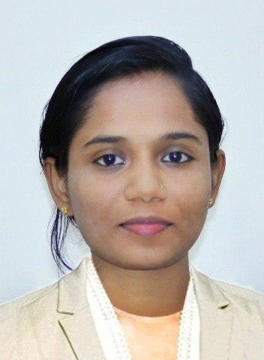

Meethu

Meethu-391783@2freemail.com

CAREER OBJECTIVE

Seeking suitable assignments in a reputed organization. If I will get an opportunity to grow along with the company and ideally utilize my knowledge, skill and experience.

CAREER PROFILE

KSEB(​Kerala State Electricity Board)​SENIOR OFFICE ASSISTANT​(March 2018 - August 2018)

JOB RESPONSIBILITIES

- Reconciliation of Bank Accounts

- Answering and directing phone calls

- Develop and maintain a filing systems(Documents controller)

- Answer phones and transfer to the appropriate staff member

- Take and distribute accurate messages

- Manage incoming and outgoing mails.

- Prepare quotation for purchase and payment

- Prepare estimation for contractor works.

- Scheduling, organizing and planning

- Initiative and resourcefulness resulting in the effective streamlining of processes and systems to improve efficiency.

A team worker with excellent communication skills, experience and a passion for getting results.

EDUCATIONAL QUALIFICATION

Bachelor of Computer Application ( BCA ) from Bharathiyar University Board of Higher Secondary Examinations (Plus Two)

TECHNICAL QUALIFICATION

- Thoroughout the knowledge of ​MS Office(Excel ,Word , Power Point)
- Have full knowledge on handling Internet and enhanced software packages.

- Good ​Typing speed
- Throughout Knowledge of ​Web Technologies
- Knowledge of languages as ​JAVA,HTML,C,C++

STRENGTHS

- Logical and analytical thinking, self-motivated.

- Keen attention to detail ensuring the accurate completion of multiple tasks by strict deadlines

- Able to work efficiently even under pressure with minimum supervision.

- Proficiency in various computer package

- Ability to communicate clearly in the English language; both verbally and in the production of good quality written documentation using MS Office application

- Strong verbal and personal communication skills.

- Outstanding interpersonal customer service leadership and organizational skills.
- Keen attention to detail ensuring the accurate completion of multiple tasks by strict deadlines

ACADEMIC PROJECT

MAIN PROJECT
Project name |  |  | : ​ATTACKER TRACING USING PACKET MARKING
Language |  |  | : ​JAVA
Front | end |  | : ​JAVA
Back | end |  | : ​MYSQL

Project Description:

The goal of IP traceback is to trace the path of an IP packet to its origin. The most important usage of IP traceback is to deal with certain denial-of-service (DoS) attacks, where the source IP address is spoofed by attackers. Identifying the sources of attack packets is a significant step in making attackers accountable.

PERSONAL PROFILE
Visa status |  | : Visit Visa
Date of Birth |  | : 15-05-1997
Age |  | : 21 Years
Languages known |  | : English, Hindi, Malayalam, Tamil,

DECLARATION

I hereby confirm that all the above informations specified by me are true and correct to my knowledge. If given a chance, I assure you to work the utmost satisfaction of my superiors and prove to be an asset for your esteemed organization.

Place:- Dubai Meethu

