2018 to 2019
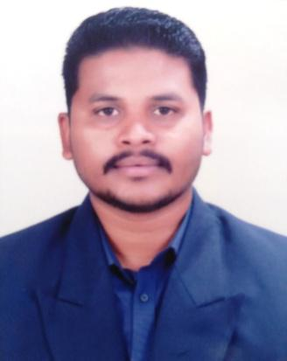
Ajinkya
Ajinkya-391813@2freemail.com

Technical support executive with 9 years india experience

EXECUTIVE PROFILE

Information technology specialist with 9 years of experience supporting software and hardware systems. Experience includes designing point of sale (POS) solutions. Background includes installing, configuring, modifying, and troubleshooting Windows operating systems and software, as well as experience determining, planning, acquiring, and implementing systems to track client information. Additional expertise gained creating and maintaining a company lan network and servers.

CAREER ACHIEVEMENTS

- Implemented wide-area network to increase availability of field data at corporate headquarters and improve communications with field technicians.

- Followed departmental procedures to purchase, configure, and install new and recycled hardware systems, maintaining corporate standards for system compatibility.
- Designed and implemented database to track network equipment, computers, servers, and software.

- Designed and maintain local area network and server administration.

LANGUAGES

English – excellent and very good command on reading,writing and speaking.

Hindi. – excellent and very good command on reading,writing and speaking.

WORK EXPERIENCE

Customer Support Executive.

Joister Infoserve Pvt Ltd, Nashik, MH

Monitor network performance and troubleshoot problem areas as needed.

Configure routers and link up with isp with technical configuration settings.

Oversee installation, configuration, maintenance, and troubleshooting of end user workstation,Hardware, software, and peripheral devices.

Ensure network connectivity of all servers, workstations, telephony equipment, and other network appliances.

Monitor and test network performance and provide network performance statistics and reports.

sales of broadband connections.

1 | P a g e

2010 to 2012

2013 to 2018
TECHNICAL SUPPORT EXECUTIVE

Aditya Computers, Nashik, MH

Set up workstations with computers and necessary peripheral devices (routers, printers etc.) Check computer hardware (HDD, mouses, keyboards etc.) to ensure functionality

Install and configure appropriate software and functions according to specifications Develop and maintain local networks in ways that optimize performance

Ensure security and privacy of networks and computer systems
Provide orientation and guidance to users on how to operate new software and computer equipment

Organize and schedule upgrades and maintenance without deterrring others from completing their work Perform troubleshooting to diagnose and resolve problems (repair or replace parts, debugging etc.)

Maintain records/logs of repairs and fixes and maintenance schedule Identify computer or network equipment shortages and place orders.

TECHNICAL SUPPORT PERSON

RCSS TRADING, Nashik, MH

Give technical support to hotels, banks, MIDC companies, and offices and do work of computer installations, repairing, and assembly and windows repairs.

Achievement - I was selected for specially bank and hotel annual maintenance service from our organization.

EDUCATION

Completed 12th Hsc ( higher secondary certificate ) in feb-2008 batch from hpt arts and ryk science collage nashik.

Completed 10th Ssc ( secondary school certificate ) in Mar-2004 batch from gokhale education society high school nashik.

JCHNPP ( jetking certified hardware & networking professional premium ) Jetking Nasik |  | June 2011 | A Grade
CCNA | Jetking Nasik | June 2011 | A Grade
Linux | Jetking Nasik | June2011 | A Grade
MS-CIT | Sai computer nashik | June 2007 | 66 %
Tally 9.0 | Sai computer nashik Oct 2007 |  | 68%
SEMINARS AND WORKSHOPS

•Attended seminars of following

- Sneh Desai (motivational speaker) seminar name-Change your life

- Anand Bansode (motivational speaker) seminar name- the limitless you.

OTHER INTEREST

Watching motivational videos,Reading Technical books,Driving car,Listening Music.

