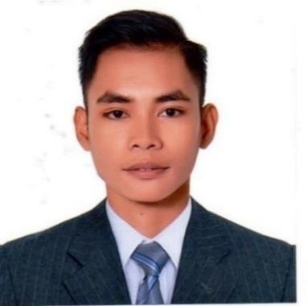
JOSHUA V. - LPT

Profession: Licensed Professional Teacher

E-mail: Joshua-391955@2freemail.com

CAREER SUMMARY

Having comprehensive knowledge of methods and procedures relating to Teaching Profession. Seeking opportunities in a reputable and respected School wherein, I may be able to work with people of high spirit and determination in fulfilling ones duty. All the while engaging in new challenges and learning experience.

WORK EXPERIENCE

December 4, 2017 – FEBRUARY 20, 2018
OFF- CAMPUS TRAINING TEACHER

SCOPE OF WORK:
- Teaching the pupils in Public school

- Teaching the core subjects and minor subjects

- Teaching the Mother tongue Language

- Making Lesson Plan for all subjects

- Making Visual aids for all subjects

- Helping the teacher in maintaining classroom management

- Helping the principal in school works

- Helping in extracurricular activities of the school

- Helping in planning for school activities

- Making TOS for the exam questions of the pupils

- Making grades of the pupils

- Preparing everyday lesson for the pupils

- Coaching the pupils for their national school contest

- Helping in reviewing the pupils for their examination

- Conduct daily observation of the pupils works

- Checking of attendance of the pupils

- Checking of test papers of the pupils

- Teaching Good manners to the pupils

AUGUST 7, 2017 – OCTOBER 30, 2017
ON- CAMPUS TRAINING TEACHER

SCOPE OF WORK
- Teaching the pupils in Private school

- Teaching the core subjects and minor subjects

- Making a lesson plan for all subjects

- Making visual aids to all subjects

- Designing classroom for engaging classroom environment

- Observing the behavior of the private school pupils

- Making TOS for the exam questions of the pupils

- Making test questions of the pupils

- Designing library of the school

- Designing playroom of the pupils

- Helping in maintaining the good attitude of the pupils

- Teaching Good manners to the pupils

- Helping in the extracurricular activity of the pupils

- Making grades of the pupils

- Working with Principals and Teachers of the school

- Checking of attendance of the pupils

- Checking the test papers of the pupils

- Teaching pupils of different grade (primary levels)

JULY 2016
READING REMEDIATION PROGRAM

SCOPE OF WORK:
- Introduce the alphabets to the pupils

- Teaching the sounds of the letter in the alphabet

- Teaching the first step in reading words

- Introduce the vowel and consonant sounds

- Teaching the CVC words

- Teaching to read and spell the basic English words

- Teaching to read a paragraph and a short story

- Observing the development of reading of the pupils

HIGHEST EDUCATIONAL ATTAINMENT

- Tertiary Course: Bachelor of Elementary Education (BEED) University of Saint Anthony, Education Department (S/Y 2014-2018) Iriga City, Philippines

- Freshman of the Year: Bachelor in Science in Information Technology (BSIT) University of Nueva Caceres (S/Y 2013-2014)

Naga City, Philippines

PERSONAL BACKGROUND

Birthday: November 28, 1995
Age: 23
Religion: Roman Catholic
Nationality: Filipino
Civil Status: Single
Language Spoken/Written: English, Tagalog

SKILL PROFILE:

- Drawing

- NC II ( Computer System Service)

- Good in oral and written English communication

SEMINAR ATTENDED:

- GRAPHIC ORGANIZERS AS THINKING TECHNOLOGY August 8, 2017

- CATERING DIVERSE LEARNERS THROUGH MULTI- GRADE TEACHING August 8, 2017

- STORYTELLING: WHAT MAKES AN EFFECTIVE STORYTELLER September 26, 2017

- BECOMING AN EXEMPLARY INSTURCTIONAL LEADER JULY 4, 2017

- STIMULATING CREATIVITY IN THE CLASSROOM: ARE YOU CREATIVE AND IMAGINATIVE? JULY 25, 2017

I hereby certify that the above information are true and correct with the best of my knowledge and belief.

JOSHUA

APPLICANT

