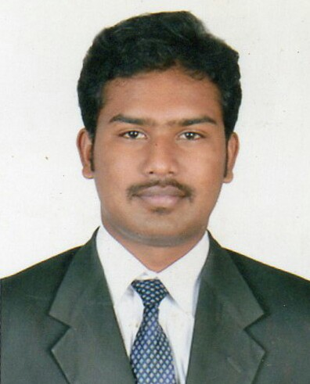
PAUL
Paul-392098@2freemail.com

CAREEROBJECTIVES:
Committed for knowledge sharing and dedication to work, also looking forward for challenging and rewarding carrier, with a right exposure and growth.

PROFILE SUMMARY:
- Overall 6 years of experience in the field of Electrical Maintenance & Instrumentation in oil &gas sector.
- Manages the Plant's operations, Projects & maintenance.

COMPANY NAME: LEWA NIKKISO MIDDLE EAST FZE, SHARJAH, UAE (OIL & GAS SECTOR)

ELECTRICAL AND MAINTENANCESUPERVISOR DECEMBER 2016 – PRESENT

RESPONSIBILITIES IN INDUSTRIAL MAINTENANCE
- Managed the diverse operation of the factory electrical maintenance department which included planning, scheduling, and supervising the activities for 20electricians.
- Organizing work schedules and maintaining worker timesheets.
- Diagnosed equipment malfunctions and completed repairs to restore equipment and maintain uptime.
- Carrying out servicing and pre – planned maintenance electrical tasks.
- Planning and scheduling the PM for all factory machineries& Generators.
- Operation & maintenance of Generators 635 KVA & 455 KVA 1500 RPM, DVR Excitation systems)
- Have an experience in MEP works.
- Provided technical support to resolve factory breakdown issues and troubleshooting of welding machines.
- Working in the various areas such as Electrical Applications, Electronics, Electrical Line terminations, Protective devices, Pneumatics & Hydraulics, PLC & Control system.
- Regular testing, inspection and installation of Fire related systems such as Fire pump, smoke detectors, sprinklers and water flow switches.(Fire & Safety)

RESPONSIBILITIES IN PROJECT WORKS
MONITOR & SUPERVISE FOR ALL THE ELECTRICAL & INSTRUMENTATION SCOPE IN CHEMICAL INJECTION PACKAGES

- Understanding of P&ID's drawings, JB termination drawings.
- Cable tray installations & cable pulling

- Installation, commissioning, operation & maintenance of instruments (Temperature, Flow pressure transmitters, Level transmitters)
- Glanding & termination of cables.
- We have done projects for ADMA, KOC, PETROFAC, SAIPEM, and ZADCO.

COMPANY NAME: SEKO MIDDLE EAST FZE, SHARJAH, UAE(OIL & GAS SECTOR)

ELECTRICAL AND MAINTENANCE SUPERVISOR MAY 2015 – DEC 2016

- As my role in the company is to co-ordinate with production team for installation of pressure transmitters and level transmitters,electrical wiring, panel erection, Installation of plunger and hydraulic double diaphragm metering pumps, hydraulic diaphragm metering pumps and heat rising JB's, pressure switches, flow switchesand Earthing installations, channeling, cabling and tray of HV and LV lines.

- Cables laying and installation of low current systems as well as working with Electrical maintenance team for troubleshooting of all industrial machineries.

- Testing / Service activities also carried out such as Flow rate identification and calibration checking, back pressure valve adjustments.

COMPANY NAME: DIVYA SPINNING MILL PVT LTD, INDIA

ELECTRICAL MAINTENANCE ENGINEER JULY 2013 – MARCH 2015

- Attending breakdowns in simplex, carding, RSB drawing, comber machines and 36 frames of
Spinning machines.

- Troubleshooting for all type of Electrical panels, relays, motors, transformers (3450 KVA/11KV,
1600 KVA & 2600 KVA TRANSFORMER) maintenances.

- Testing assistant work for all type of LV panels, HV panels, switch yard CT’s, PT’S , Breakers, HV &LV Panel, Isolators, all type of erection, bus bar arrangements

- Monthly routine maintenance for Battery bank, various type of chargers & UPS maintenance of
ACB‘s, VCB‘s, breakers.

PROFESSIONALQUALIFICATIONS

COURSE : B.E (Electrical & Electronics Engineering)
INSTITUTE : Jay Shriram Group of Institutions, INDIA
YEAR OF PASSING : May 2013
PERCENTAGE : First Class (7.3 CGPA)

COURSE : Diploma in Electrical & Electronics Engineering
INSTITUTE : Erode Institute of Technology – Erode, INDIA
YEAR OF PASSING : APRIL-2010
PERCENTAGE: First Class (72%)

EDUCATIONAL PROFILE:
- 10thstandard from DeivanaiPerumal Higher Secondary School, March 2007
Mark Percentage: 72%

COMPUTER PROFICIENCY:

- Microsoft Office (Word, Excel, Outlook,Power point), SAP

CERTIFICATES:
- Successfully completed the 60- hour’s course of Introduction in panel board control conducted in the year of 2014 January in Career Developers atCoimbatore.
- Successfully completed in-plant training in Alpha Engineers manufacturer of control panels at
Erode.

LANGUAGE PROFICIENCY
Language | Spoken | Written
English | EXCELLENT | EXCELLENT
Tamil | EXCELLENT | EXCELLENT
Malayalam | BETTER
Hindi | BETTER

ENGINEERING SKILLS

- AutoCAD

- PLC

- SCADA

KEY ABILITIES

- Analytical

- Well work under pressure as a team player

- Innovative thinking

- Well organized

KEY QUALITIES

- Responsible

- Respectful

- Self-motivated

- Ambitious

PERSONAL DETAILS:

FATHER’S NAME : N.RAVICHANDRAN
DATE OF BIRTH : 25 JUNE 1992
NATIONALITY : INDIAN
MARITAL STATUS : MARRIED
VISA STATUS : EMPLOYMENT VISA

