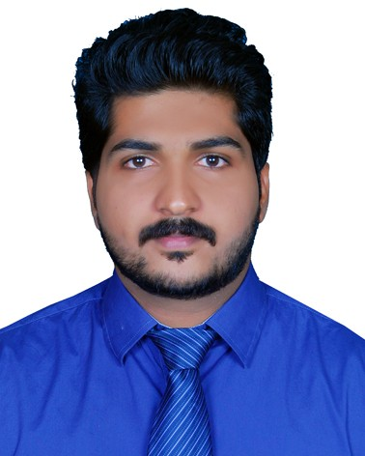
Dhanesh .

Dhanesh-392182@2freemail.com

Objective
I intend to pursue a promising and challenging career which will enable me to provide best of my technical, analytical and professional skills and can sharpen my current skills and knowledge and where I can have a good scope for learning and implementing new technologies.

Education
2013-2015 Master of Technology in Communication (M.Tech).
specializationCommunication Engineering and Signal Processing (CGPA - 8.1).
College Government Engineering College, Wayanad, Kerala, India, Affiliated to University of Kannur.

2009-2013 Bachelor of Technology (B.Tech).
specializationElectronics and Communication Engineering (64.9 % ).
College Government Engineering College, Wayanad, Kerala, India, Affiliated to University of Kannur.

2008 Higher Secondary Examination in Science.(80 %.) SchoolGoverment H S S Udinur, Kasaragod, Affiliated to Kerala State Board.

2006 Secondary School Leaving Certificate Examination.(80 %.) SchoolGovermnet H S S Udinur, Kasaragod, Affiliated to Kerala State Board.

Technical Qualifications
Obtained Advanced Training In Industrial Automation (ATIA) from Technocrat Automa- tion Pvt Limited (IAO Accredited), Chennai. With 6 months hands on practical experience in Industrial Automation Tools specializing in PLC, DCS, SCADA and VFD.
•

Work experience
Possess a good practical experience in Industrial Automation Tools specializing in PLC, DCS, SCADA and VFD.
•
- Experience in plc programming for HVAC system.(Blue horizon services)
- Have the experience in the preparation of autoCAD drawings.
- Experience in Design Simulation and Fabrication of Microstrip Patch Antenna.
Worked in UTL Technologies Ltd. Bangalore as Technical Consultant in Telecom, Net- working and Optical Fiber.
•

- Splice optical fibers, optimize splicing procedure of specialty fiber.
- Test fiber- optic components and system and documents results.
- Worked with copper and fiber optics cabling, network and switching systems.
Worked as Guest Lecturer in Government Polytechnic College Trikaripur in Electronics department .
•

Master thesis

Title Design of Novel Low-Profile Microstrip-fed Compact Triple Band-notched Ultrawide Band Antenna For UWB Applications.
Description Designed a Trapezoidal Antenna for UWB applications, which covers the frequency range of 3.1-10.6 GHz and Band stop filters are introduced to avoid interference to the existing communication systems such as WiMAX , WLAN and X-band frequencies. Which is Simulated by Ansoft HFSS and fabricated.

B.Tech. Project.

Title Fingerprint Based Attendance System .
Description This project aim at introducing biometric capable technology for use in automating the entire attendance system for the students pursuing course at an educational institution.

Research Publication
V. K. Dhanesh "Trapezoidal Antenna With Triple Band-Notched For UWB Applications", International IEEE India Conference INDICON , Dec. 2016 .

Skill Set
PLC (Programmable Logic Controllers), DCS (Distributed Control System) Programming languages such as LD (Ladder Diagram) and FBD (Functional Block Diagram).
•
Hands on Practical exposure in brands as Siemens, AB (Allen Bradley),ABB (Asea Brown Boveri), Honeywell, Schneider, GE Fanuc, Keyence, Omron, Messung, Mitsubishi, Intouch,and Delta.
•
SCADA (Supervisory Control and Data Acquisition) Screen designing, PLC interface, Data collection and storage( Wonderware Intouch and Intellution Fix)
•
- HMI (Human Machine Interface) Screen designing, PLC interface (ABB).
- VFD (Variable Frequency Drive) Commissioning and Troubleshooting (ABB).
- Pneumatics and Field instruments
- MATLAB, HFSS (High Frequency Structure Simulator), Microsoft Office, Latex.
- C, VHDL(VHDL Hardware description language ).
- TMS320C6713 DSP Starter Kit, FPGA (Field programmable gate array) Spartan-3E kit.
- Preparation of autoCAD and ElectricalCAD drawings.

Achievements and Extra Curricular Actiites
Secured Score of 304 in Graduate Aptitude Test in Engineering (GATE-2013) for Electronics and Communication stream.
•
Participated The Training Programme of Additional Skill Acquisition Program Of the course Optical Fiber Splicer, Department of higher education for skill course in the Telecom sector.
•

