Fozia
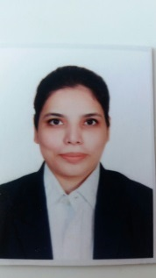

Fozia-392203@2freemail.com

CERTIFIED PSYCHOLOGIST SCHOOL TEACHER

Teaching professional with a 7-years accomplished career track as a Psychologist school teacher in one of the distinguished school in Pakistan. Offer a proven track record of commended performance teaching grades 1-10 grades, with a passion for education and an unwavering commitment to optimizing student and school success.

CORE COMPETENCIES

— Dealing with Autism  — Difficulties in remembering  — Behavioral Problems  — Developmental learning difficulties  — Personality issues  — Adjustment issues | — Mood Disorders of students  — Child hood emotional disorders  —Difficulty in conceptual formation  — Attention difficulties  — Special Needs Students
Professional Experience
Beaconhouse School Systems (International), Hyderabad, Sindh, Pakistan (From August 2012 to Till date)

- To deal with various behavioural issues, learning difficulties, disabilities, emotional problems, and other concerns.
- To provide counselling, mentoring, and instructional services to help promote wellness by reinforcing strong communication, problem-solving, anger management, self-regulation, or social skills.
- To help out the students who are facing learning disabilities
- To increase the achievement by assessing the abilities and devising the best instructional strategies for optimal learning.
- Frequent collaboration with teachers, parents, administrators, and other professionals in the school building to strengthen connections between home and school for all students
- To evaluate eligibility for special education services, teaching parenting skills, making referrals to help coordinate community support, designing student progress monitoring systems, and implementing school-wide prevention programs.
- To promote school policies that will ensure the safety of students by reducing school violence, harassment, and bullying.
- Talking to students and fostering positive mental health and personal growth.
- To correct behavioural disorders

Personal Details
Marital Status: Single
Nationality: Pakistani
Date of birth: 18th Feb, 1980

