CURRICULUMVITAE

SARAN
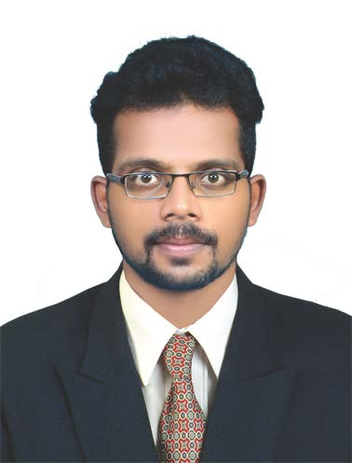

Email : saran-392214@2freemail.com

Objective

To work in a challenging environment, where I could utilize my skills and knowledge to the best of my ability and also to contribute positively for my personal growth as well as the organization.

WORK EXPERIENCE (3year 4 months)
- Company name : SUNTECH CONSTRUCTIONS
- City : Varkala,Trivandrum
- Projects : APARTMENT (G+4Building) in Trivandrum
- Dates worked : 11th January 2016 to 10th June 2019
- Designation : Site engineer

JOb responsibilities

- Check plans, drawings and quantities for accuracy of calculations.
- Quality control of concrete works & all civil works.
- Oversee health and safety matters on site.
- Setting out of layouts, leveling and survey the site.
- Oversee the selection and requisition of material.
- Should be punctual in time and made the workers punctual.
- Checking technical designs and drawings to ensure that they are followed correctly.
- Planning according to the project schedule of cost as per BOQ.
- Submission of daily productivity report.
- Monitor to finish the project on timing as per schedule.
- Allocating duties to foreman and lead man of daily activities.
- Inspect all the works and get approval from consultants.
- Reporting day-to-day activities to the management by providing DPR.
- Ensure that all materials used and work performed are in accordance with thespecifications.
- Day-to-day management of the site, including supervising and monitoring the sitelabour force and the work of any subcontractors.
- Planning the work and efficiently organising the plant and site facilities in order tomeet agreed deadlines.
- Liaise with any consultants, subcontractors, supervisors, planners, quantity surveyorsand the general workforce involved in the project.
- Execution all types of civil works:

sofTWARE SKILL SET

  - Auto Cad 2D & 3D
  - 3Ds Max Design
  - Google Sketch up.
  - Adobe Photoshop
  - Microsoft Office

eDUCATIONAL QUALIFICATION

  - CompletedDiploma in CIVIL ENGINEERING from Sree Narayana Polytechnic Collage Kottiyam, Kollam 2012-2015

  - Completed VHSC Civil Construction and Maintenance - March 2011

AREA OF INTREST

    - Ready to learn new concepts
    - Ability to work individual as well as a part of team
    - Willingness to take responsibility and stick to deadline
    - Construction and Project Management
PERSONAL DETAILS

Gender : Male
Date of Birth : 12/03/1993
Marital Status : Unmarried
Languages Know : English, Hindi, Malayalam&Tamil
Nationality : Indian

