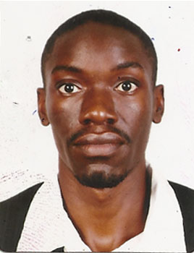
Curriculum vitae

Personal details
Full Names ; Andrew Kamau
Date of Birth; 22 June 1988
Nationality ; Ugandan
Martial status; Married
Gender ; Male
Religion; Muslim
Visa status; visit visa
Email : andrew-392231@2freemail.com

Career objectives
Seeking a suitable position where I can utilize my exceptional hospitality skills and ability to provide courteous service to the customers in order to maximize revenue

Education qualification
School | Award | year
Buganda Royal institute | Certificate in MVT | 2013
Kansanga Secondary sch | UACE | 2008
Kansanga Secondary | UCE | 2006

WORKEXPERIENCE summary
I have 6 years work experience in different disciplines and responsibilities assigned to me in my history of work which includes 2 years of housekeeping in the united Arab emirates and my country Uganda as presented below
Company

HOUSEKEEPING AT Al Suwaidi Catering and Hospitality llc ABU DHABI 2016/2018
  - Responsibilities
- To clean army officer accommodation, cafeteria, senior officer offices
- To help the waiter in organizing the cafeteria before the officers come to eat and also clean after it’s use.
- Sweeping the office compound and the parking areas
- Emptying the trash bins both in the offices and outside

HOUSEKEEPING AT Hotel International Uganda 2009/2013
  - Responsibilities
- Cleaning customer rooms, changing bed sheets, cleaning the washrooms
- Mending and repairing hotel and stuff uniforms. Bed linen , table clothes and curtains
- Stewarding with the kitchen crew i.e general cleaning of the kitchen
- Represent the team leader whenever need arises i.e attending to customer requests
WAITER AT Sheraton Hotel Uganda 2012/2009
Responsibilities
- Taking customer orders
- Serving at the banquet and buffet
- Making coffee or expresso, cocktail drinks
- Doing room service upon customer requests

Special Abilities
- Driving
- Motor mechanics
- Tailoring and mending
- Knowledge of Cleaning chemicals
- Computer skills i.e Microsoft packages

I will provide referees on request.
I hereby declare that the above information is accurate

