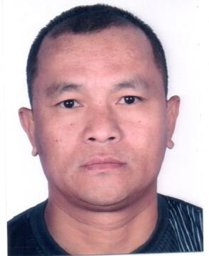
CURRICULUM VITAE

CHOK

Email: chok-392295@2freemail.com

POST APPLIED FOR: FORKLIFT OPERATOR &DRIVER

Objective:
To seek a position in the organization that is challenging and stimulating whereby I can render a valuable productive contribution and achieve productive contribution and achieve personal growth.
Personal Details
- Father Name : Samsher Gurung
- Date of birth : 06.01.1970
- Sex : Male
- Religion : Hindu
- Nationality : Nepal
- Marital Status : Married
- Languages Known : English, Urdu , Hindi & Nepali
Educational Qualification
- High School License Details Valid For UAE (No- 7)
- Issue Date : 02.07.2014
- Expiry Date : 01.07.2024
- Place of Issue : Sharjah
Working Experience
- Presently working as a Forklift Operator in, Dubai, UAE from 1 year 3 months
- Worked as a Warehouse Assistant in Knightbridge Chemicals FZE Sharjah UAE for 8 years.
- Worked as a same position in Navio Shipping llc, Jebel Ali Free Zone.

