CURRICULUM VITAE
Vara |  |  |  |  | 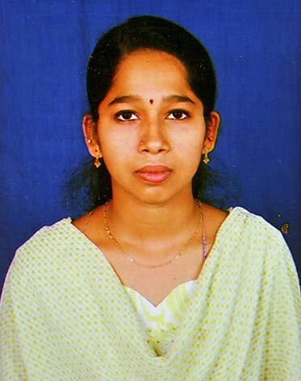
Email Id: vara.392304@2freemail.com

OBJECTIVES:

To Work with an organization, offering a responsible challenging, creative working Profile so as to prove my skills in my discipline.

CURRENT STATUS:

Currently residing at Sharjah with Visit visa upto the validity of 02nd September 2019.

EDUCATIONAL QUALIFICATION:

- SSLC - Karnataka Secondary Educational Board
- PUC - Pre University Bangalore

COMPUTER SKILLS:

- Basic Computer Applications
- With advanced Micro Soft Excel (Formulas, V-lookup, H-Lookup, Pivot, etc..,), MS Word, PPT (Basic).

WORK EXPERIENCE:

- Worked as Tele caller in M/S Angel broking stock marketing company in Bangalore from April 2010 to April 2011.
- Worked as a Customer service representative in M/S Ten on Ten Education Pvt Ltd Bangalore from April 2011 to May 2012.
- Worked as receptionist cum asst accountant in M/S GIFT fertility Center Bangalore from May 2012 to July 2013.
- Worked as Sr. Executive Finances and Office Administration with M/S Fiesta Car Rentals & Logistics Pvt Ltd Bangalore from July 2013 to March 2019.
- Worked as Part Time receptionist at Apple Baby Clinic from April 2010 to January 2018

Rolls & Responsibility of Current organization (Fiesta Car Rentals)

- One point of contact for all Bills receivables.
  - Posts customer payments by recording cash, cheques, and credit card transactions.
  - Updates receivables by totaling unpaid invoices.
  - Maintains records by microfilming invoices, debits, and credits.
  - Verifies validity of account discrepancies by obtaining and investigating information from sales.
  - Resolves valid or authorized deductions by entering adjusting entries.
  - Resolves invalid or unauthorized deductions by following pending deductions procedures.
  - Resolves collections by examining customer payment plans, payment history, credit line; coordinating contact with clients processing invoices for payments.
  - Summarizes receivables by maintaining invoice accounts; coordinating monthly transfer to accounts receivable account; verifying totals; preparing report.
  - Protects organization's value by keeping information confidential.
  - Accomplishes accounting and organization mission by completing related results as needed.
- One point of contact for all Bills payables.
  - Keeping track of all payments and expenditures, including payroll, purchase orders, invoices, statements, etc.
  - Reconciling processed work by verifying entries and comparing system reports to balances
  - Maintaining historical records
  - Paying employees by verifying expense reports and preparing pay checks
  - Paying vendors by scheduling pay checks and ensuring payment is received for outstanding credit; generally responding to all vendor enquiries regarding finance
  - Preparing analyses of accounts and producing monthly reports
  - Continuing to improve the payment process
- One point of contact for all vendor managements
  - As it’s a transport industry and our major expense if releasing payments to our drivers.
  - Ensure to cross his duties performed and billed to clients and arrange to release vendor payment on time.
  - Cross verify the vendor’s records like fuel advance and all other advances to be recovered before releasing his payment.
- One point of contact for all office administration and HR Assistances
  - Maintaining current HR files and databases
  - Updating and maintaining employee benefits, employment status, and similar records
  - Maintaining records related to grievances, performance reviews, and disciplinary actions
  - Performing file audits to ensure that all required employee documentation is collected and maintained
  - Performing payroll/benefit-related reconciliations
  - Performing payroll and benefits audits and recommending any correction action
  - Completing termination paperwork and assisting with exist interviews
  - Salary processing based on Punch Record and attendance copies.
- Currently handling as one point of all MIS of our Major clients like M/S SONY, SYMANTEC, HUAWEI, HEXAWEAR, FIDELITY INFORMATION SERVICE, GROUPON. Etc,
  - One point of contact towards any billing clarification.
  - Ensure to collect agreements from new clients, and renewal of existing client’s agreements once it is expired.
  - Follow ups for payments.
  - Ensure to clear all queries raised by clients to process our invoices.
  - Updating the received payments in finance database and provide accurate outstanding data to the management.
- All other day to day activities.
  - Taking care of day to day office expenses.
  - Petty cash handling.
  - Attendance data base maintenance.
  - Coordinating with employees to their queries.
  - Housekeeping supervision.
  - Front Office maintenance.

SKILLS
- To work with self confidence
- Ability to generate team spirit in a group and work with harmony
- A consulting approach to problem solving
- Vendor Management
- Procurement co-ordination
- Fast learner and Pro active team player.
HOBBIES:

- Reading books
- Listening Music

PERSONAL PROFILE

Name : VARA

Date Of Birth : 03/02/1993

Gender : Female

Nationality : Indian

Marital Status : Married

Languages known

- Read, Write, Speak : English, Tamil, Kannada,
- Speak : Telugu
- Understand : Malayalam & Hindi

DECLARATION

The above mentioned information is true and correct to the best of my knowledge and belief.

Thanking You,

Date: Yours Faithfully,

Place: (VARA)

