CURRICULUM VITAE
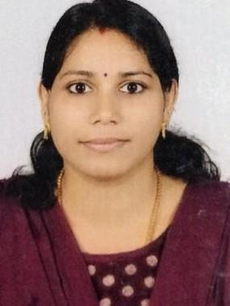

DEEPTHI

Deepthi-392337@2freemail.com

CAREER OBJECTIVE

To work with a reputed institution that can enhance Teaching experience and skills

ACCADEMIC QUALIFICATIONS

QUALIFICATIONS |  | UNIVERSITY | YEAR | PERCENTAGE
M A MALAYALAM | SREE SANKARACHARYA UNIVERSITY OF SANSKRIT |  | 2014 | 75%
 | ,KERALA
B Ed MALAYALAM | CALICUT UNIVERSITY ,KERALA |  | 2012 | 62%
B A MALAYALAM | CALICUT UNIVERSITY,KERALA |  | 2010 | 63%
HIGHER SECONDARY | BOARD OF HIGHER SECONDARY EDUCATION |  | 2007 | 70%
EDUCATION | ,KERALA
SSLC | BOARD OF SECONDARY EDUCATION , KERALA |  | 2005 | 76%
ADDITIONAL QUALIFICATIONS

CERTIFICATES | DATE OF QUALIFYING
NATIONAL ELIGIBILITY TEST-UGC-INDIA | 21-04-2014
STATE ELIGIBILITY TEST-KERALA | 07-09-2016
KERALA TEACHER ELIGIBILITY TEST -KERALA | 05- 10 2013

EXPERIENCE

1. | One year Experience in Technichal High School West hill | (2017-2018)
2. | Six months Experience in Zamorin’s Guruvayurappan college Kozhikode (2015 -2016)

PERSONAL SKILL

- Honesty

- Team spirit

- Accepting Challenges

PERSONAL PROFILE

Date of Birth

: 18-05-1990

Sex

: Female

Nationality

: Indian

Marital Status

: Married

