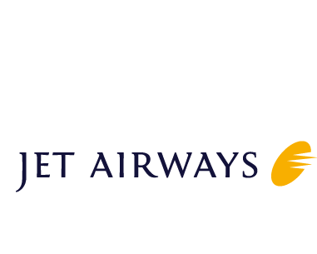DAVID

DAVID-392339@2freemail.com

Summary

Experienced Customer Service agent with extensive knowledge in commercial airline operations including scheduled & charter services. Highly task oriented, meeting the flight schedule, deliver quality passenger services and meet the service quality expectations of the air carrier, customers & flight crew

Highlights
- 11+ years of delivering excellence in Airline Services.
- Expertise to lead, manage and develop the provision of service in the areas of passenger, ramp, load control and operations.
- Proficiency in use of SABRE Global Distribution systems
- Well versed with working in a fast paced environment with time constraints to meet published departure goals.
- Excellent people skills including sound verbal and written communications, focused on delivering effective solutions to customers ensuring seamless operations.
- Highly felxible in adapting to working hours as per airline schedules.

Experience

SENIOR AIRPORT CUSTOMER SERVICE AGENT
08/2007 – PRESENT

JET AIRWAYS(INDIA)LTD.
COCHIN INTERNATIONAL AIRPORT, INDIA

  - Process tickets, check baggage, monitor carry-on baggage for size and quantity, and assign seats.
  - Supervise the loading and unloading of baggage and cargo.
  - Track information on flight bookings and cancellations & handle denied boarding situations, solicit volunteers, re- accommodate customers.
  - Manage reservations and help passengers find best alternatives in case of disruptive flights.
  - Provide information on arrival and departure times, boarding procedures, carry-on regulations and seating arrangements & sensitively manage any customer service issues as necessary.
  - Coordinate with passengers for mishandling baggage queries.
  - Routine greeting of passengers at check in counters and assist customers who need assistance boarding
  - Prepare daily reports of customer activity.
  - Monitor Ramp area functions.
  - Manage regular announcements concerning flight arrivals and departures.
  - Respond to customer inquiries in person and online.

Trainings & Certifications
  - FIATA Introductory Certification (6 months) 2006 – Air India.
  - Jet Airways Basic SABRE reservations and ticketing training - Mumbai in 2007
  - Jet Airways Advanced SABRE Reservations and ticketing training - Mumbai in 2009
  - Basic Airport handling training - Mumbai in 2009.
  - Sabre Sonic Check –In (SSCI) training for Jet Airways - Mumbai in 2011
  - Automated Exchange and Refund (AER) training for Jet Airways - Mumbai in 2011
  - Back to Basic training for Jet Airways - Mumbai in 2012
  - Load officer training for Jet Airways - Mumbai in 2013

Education & Personal Details
  - Bachelor’s Degree in Arts-2006 (University of Kota, India)
  - Born on 18-Dec-1980. Married.
  - Indian National. Fluent in English, Hindi and Malayalam.

