CURRICULUM VITAE

PERSONAL DETAILS

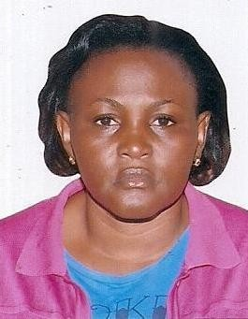
NAME : Sauya

MAIL : sauya.392350@2freemail.com

NATIONALITY : Ugandan

SEX : Female

VISA STATUS : Visit Visa CURRENT RESIDENCE: Dubai, UAE
LANGUAGES : Fluent in English SALES ASSOCIATE
Sauya is an expert at providing exceptional customer service and closing sales.

KEY SKILLS AND COMPETENCIES
    - Able to engage and speak to customers.

    - Superb people and sales skills.

    - Customer service experience in a retail environment.

    - Knowledge and experience in using computer systems.

    - Communicating effectively and professionally.

    - Can work at a sustained pace and produce quality work.

WORK EXPERIENCE

Designation: Sales Associate, 4 years
Duties:

    - Responding quickly and resourcefully to customer requests or concerns.
    - Using suggestive selling techniques to increase sales.
    - Giving information to customers about products.
    - Up selling and making recommendations to customers.
    - Serving multiple customers in a short period of time.
    - Carrying out re-merchandising, display, price markdowns duties.
    - Accurately completing cash register transactions.
    - Receiving store deliveries.
    - Representing the store in a professional and positive manner.
    - Creating and maintaining long-term relationships with regular customers.
    - Assisting in all store administrative tasks.
    - Taking care of the customers’ needs while following company procedures.
    - Executing marketing and visual merchandising initiatives.
    - Occasionally opening and closing the store.
    - Organizing the display of merchandise.
    - Assisting customers with choices by providing them with information about products.
    - Participating in physical inventory counts.
    - Adhering to all store retail policies and procedures.

ACADEMIC QUALIFICATION
      - High school Certificate
HOBBIES: Making Friends, Watching Movies, Travelling and Music.
REFEREES: Available upon request
DECLARATION: I hereby declare that the above information is correct up to my knowledge and I bear the responsibilities for the authority of the same.

