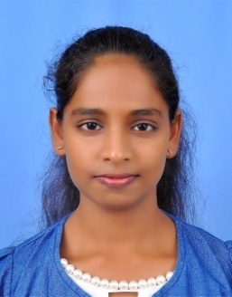
CAREER OBJECTIVE

A positively motivated, energetic team player who has a strong desire to grew a career in the field of early child hood education. Will always ensure that each child gets as much individual attention as possible, and is committed to raising standards and maximizing pupil progress. has a long track record of delivering high quality care and learning opportunities to children aged between two and ten years old, and is more than willing to assume a ultimate responsibility for the development of children under her care.

CAREER OBJECTIVE
Young, energetic, skilled cashier with 2+ years of experience in providing great customer service, handling cash, and processing transactions. Aspire to utilize my knowledge and experience to be a high-quality, efficient, and effective personnel in your esteemed company.

CONTACT
Harshini-392364@2freemail.com

WORK HISTORY

Busy Bees Nursery, Rathnapura ,Sri Lanka
2017 January - 2017 May

EDUCATION

- Diploma in primary teaching

- Got through GCE Advanced Level with 3 distinct passes including Economics, English, Sinhala

- Got through GCE Ordinary Level with 10 distinct passes including Science, Mathematics, English.

- Worked as a nursery assistant teacher.
- Planning activities based on a Child’s interest.
- Maintaining pupil attendants’ records.
- Maintaining the appearance and decor of the classroom.
- Preparing and arranging pre- class materials.
- Participating in school events.
- Keep strong bonds with their Parents.

Lyceum International School, Rathnapura, Sri Lanka
2017 May – 2019 June
2017 January – 2019 May

- Worked as a primary assistant teacher.
- Worked as a subject teacher.
- Teaching children through structured play.
- Developing child’s curiosity and knowledge.
- Submitting weekly lesson plans.
- Motivating and stimulating children’s learning abilities.
- Tidying up the classroom at the end of each days.
- Ensuring the health, safety and wellbeing of the children.
- Developing a well-managed, child oriented learning curriculum.
- Abiding by all local regulations as well as safety protocols.
- Building relationship with parent.
- Updating classroom bulletin boards with children’s works.
- Organizing and participating to the school events.

KEY SKILLS
Communication skills
Knowledge on sale software

Handheld scanning devices
Prioritization

Teamwork

PERSONAL DETAILS

- Name In Full : Athurugiriyage Harshani Sakunthala
- Date Of Birth : 29th 0f September 1994
- Gender : Female
- Age : 24 Years
- Nationality : Sri Lanka
- Civil States : Married

