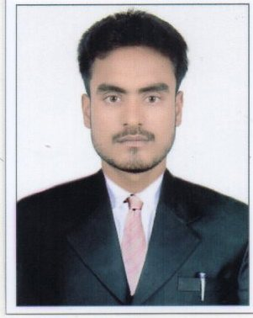
CURRICULUM VITAE

DURGESH
E-mail- durgesh.392368@2freemail.com

Carrer Objective :
To take up a challenging career and grows with honesty, loyalty, good relationship and best performance and translate my experience, knowledge, skills and abilities into value for an organization.
To participate as a team member in a dynamic work environment focused on promoting business growth by providing superior value and service.
To obtain a responsible career in life where I could optimally utilized my education qualification as well as gained professional experience for making significant contribution in a progressive and dynamic organization.

Educational Background :

Post graduate (International Economics)
- Dr. Ram Manohar Lohiya Avadh University Faizabad Uttar Pradesh India.
- Jul 2015- Aug 2017

Secondary Education
- Bharti Inter College Bikapur Faizabad Uttar Pradesh India,
2011-2012

Relevent Skills :

- Electronic Data Processing Knowledge

- M.S Office : Excellenet skills in editing typing and maintaining document,
- Power Point Presentaion : Extra ordinary skillsin creating power point presentation, Excellent presentaion skills.
- Excel Spreadsheets : Professionally trained in using MS EXCEL skills. Excellent skills to create andmaintain Excel sheets on daily basis.
- E-MAIL
- JAVA
- C+ Language

Personal Information :

Date of Birth : 15-04-1995
Gender : Male
Marital Status : Single
Nationality : Indian
Languages :

- Hindi : Mother Tongue
- English : Fluent in speaking and writing
Refrence :

- Will be provided on demand
Refrence

DECLARATION

I hereby, declare that all the information given above is true & correct to the best of my knowledge.

DATE :
PLACE : DURGESH

