 |  |  | A B O U T M E |  |  |  | 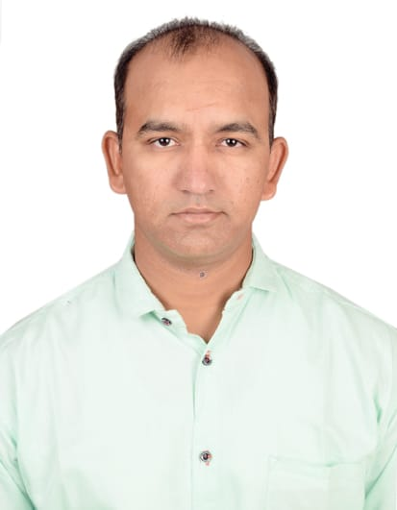  Vijendra  - office executive  Objective  To achieve professional excellence and enhance my expertise in the relevant field by joining with a dynamic motivated team that works towards the growth of the organization.  Experience  senior associate (  (Aug2011 – May 2012)  Maintaining daily MIS and circulate up to state level.  We are in the head branch so coordinate with other branches ona daily basis for collecting MIS data.  Login of files into the FINNONE application for loan processing.  Preparing CAM (Credit Appraisal Memo) of a client for forwarding.  We checked the creditability of a customer by visit or by  telephonic conversation.  Frequently used word processing, spreadsheet, database, and presentation software.  Proprietor  (July 2012 – April 2019)  Doing all works which is essential to operate a firm like sales, marketing, manufacturing,labor management, accounts, payment collection, customer handling and much more…  Assistant Manager  (March 2009 – July 2011)  Assisted with team building initiatives and overall support  for maintenance of organizational culture and employee morale.  Compiled and analysed sales and marketing reports.  Frequently used word processing, spreadsheet, database and  presentation software.  Oversaw inventory and office supply purchases.  Skills  Microsoft Office.  Communication skills.  Database management.  Result oriented.
I am versatile and hardworking Administrative assistant driven to improve productivityand customer relations with attention to detail and a professional demeanor.
 | C O N T A C T
 |  | Vijendra.392371@2freemail.com
 |  | E D u c a t i o n

ICFAI University
Diploma in Business management

2008

vikram university
Bachelor of Science

2006

