S

SMITHA
Sales, Marketing & Logistics Support Professional

Accomplished and quality-focused professional, offering more than 8+ years record of demonstrated success in Sales and Marketing support as well as highly skilled in Logistics operations and business administration. Adept at identifying and understanding key drivers and structuring business support and service solutions to fulfill customer needs. Proven aptitude in planning and coordination, office management and document control. Shown enthusiasm for work with a propensity for excellence; committed towards producing innovative and quality results and contributing to the success of the organization in an efficient and professional manner.

Email: smitha.392387@2freemail.com
Profile Summary

Achievement-driven Professional offering over 8+ years of commendable success in supporting Trading, Import- export of the Consumer Electronics, Sales & Marketing, Strategic planning and product development.
Proficiency in increasing customer satisfaction level through continuous interaction and ensuring the timely service is provided ensuring optimal utilization of resources
Expertise in conceptualizing & implementing competitive strategies for Logistics and Sales operations, developing as well as expanding market share towards the achievement of revenue & profitability targets
Excellent interpersonal skills with the capability to relate to people at any level of business Well versed with Dubai Customs procedures and Import Export regulations.

IT Skills |  |  | Key Skills
MS Office [ Excel, Word, PowerPoint, Outlook] |  |  | Sales & Marketing Support
Visual Basic. SQL Server, ASP .Net
 |  |  | Logistics Operations Management
Soft Skills |  |  | Procurement
 |  |  | Dubai Trade Procedures
Attention to Details | Team Player | Analytical
 |  |  | Customer Relationship Management
Collaborator | Communicator | Planner | Business Correspondence
Education |  |  | Documents Control
Post-Graduation in Master of Computer Science (M. Sc) – 2003-2005 |  |  | Vendor Management
Assumption College, Mahatma Gandhi University Kerala
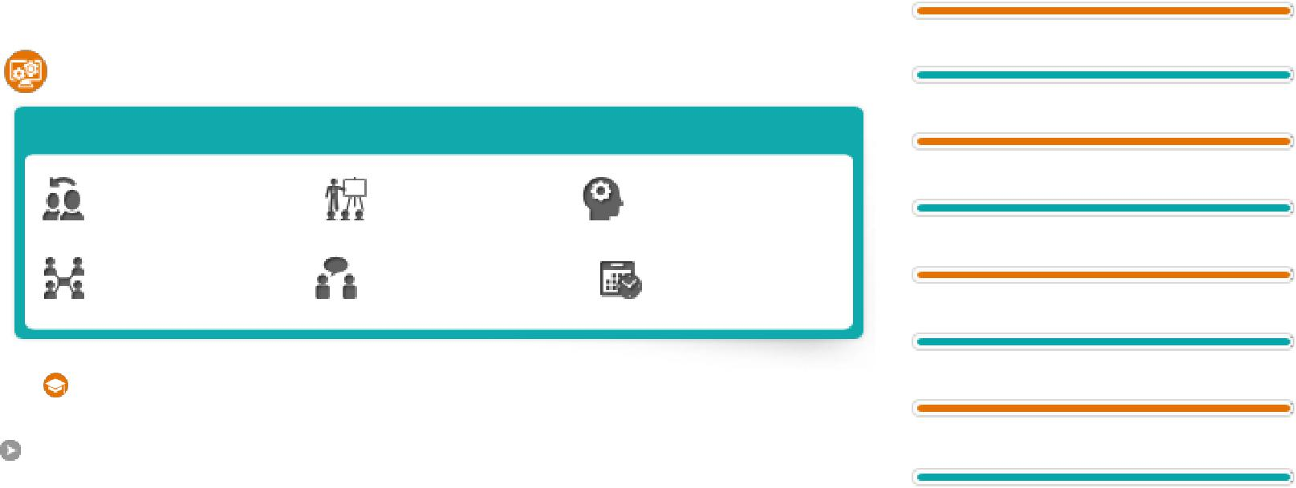
Contract Negotiations
Graduation: BSc. Computer Science [ B.Sc.] –2000-2003 Vivekanandha College of Art & Science, Periyar University, Tamil Nadu.

Certification & Academic Projects
Software Testing course (Manual Testing and Automated)
SQTL, Bangalore

Post-Graduation Project: Vacancy Management System
[ASP.NET, SQL Server 7.0]

Page 1 of 2

Career Timeline

2006 2008 2012 2015 2018

Software Programmer (2006 -2008) | Office Administrator (2012-‘15) → Logistics Coordinator (till-‘18)
 | 2012 | 215 | 2018
Taurus Hard Soft Solutions Pvt. Ltd, Bangalore, India | Island valley Electronics LLC, Dubai, UAE

Work Experience

Since Oct’ 2012 with Island Valley Electronics L.L.C, Dubai as Logistics Executive [ 5 years 10 months] Joined as Office administrator and promoted as Logistics Coordinator

Product: Consumer Electronics /Home Appliances Communications Solutions – Mobiles Phones/ Tabs /Memory Devices Brands: Nikon, Canon, Samsung, LG, Fuji, Panasonic Etc. Own Brand: Seeken Key Result Areas:

Sales & Marketing Support: Support Sales and Marketing members in planning and implementing sales, marketing and product development programs and responding to customer queries with efficient coordination.
Logistics Operation: In charge of imports & exports operations of the company, ensure that the inbound and outbound movement of goods are executed smoothly, quickly, and accurately with effective and efficient coordination with other departments.
Problem Solving: Serving customers with congeniality addressing issues and solving problems during the process.
Cost Management: Negotiate prices with logistic & shipping companies and freight forwarders to ensure availing the best market rate.
Import Export Documentation: Ensure that documentation for import and export of all equipment and materials are processed in accordance with border / customs (MIRSALII ) / Free Zone rules, regulations and compliance. Inventory Management: Assist in delivering key Inventory optimization through providing accurate data analysis for moving/non-moving or excess stock items.
Management Reporting: Recording, Maintaining and Preparation of MIS Data for management regarding logistics and transport cost, Inventory reports, insurance claims and correspondence cost.
Vendor Management: Coordinate with vendors, freight forwarders, Govt. authorities and insurance providers on authorization letters, cost approvals and invoices settlement.
Highlights:
Improved Documentation and Control, streamlining logistics process.
Implemented cost effective methods in procuring services and shipments.
Supported team in marketing events and promotional activities.
Expanded network: Developed and maintained a working relationship with competitive service providers.

Sep 2006- Mar 2008 with Taurus Hard Soft Solutions Ltd, Bengaluru, India as Software Engineer Product : SCIAC- SCIENTIFIC ACCOUNTING SOFTWARE Function : Software Programmer / Tester.

Client: Indian Institute of Science (IISc) , Bangalore
Role: System study, Design and Development of database and forms. / Team Size: 5
Environment : VB 6, SQL Server 2000, Crystal Report 8./ Team Size :5
Description: A LAN based application designed to manage the complete financial transactions of Finance & Accounts (F&A) department of IISc. The package automates the entire financial activities of various sections and enables to regulate and manage funds from various Government Establishments to IISc and generate reports in various formats as required by Auditor General of India. Providing report on the funds flow, utilization and timelines with detailed parameters.
Personal Details

Date of Birth: 5th July 1982
Driving License: Yes
Marital Status: Married

Nationality: Indian
Languages Known: English, Malayalam, Hindi , Tamil.

Visa Status: Husband Visa

Page 2 of 2

