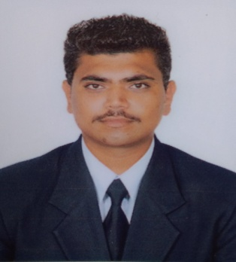
CURRICULUM VITAE

sunil
E-mail id: sunil.392393@2freemail.com
Job Objective: -Humble seeking to be a part of an organisation where I can have a challenging carrier to contribute best of my knowledge, ability and skill for innovative, resoureful attitude.
EDUCATIONAL QUALIFICATION DETAIL
- 10thhas been passed from P.S.E.B , Mohali year of 2009
- 10+2 has been passed from P.S.E.B, Mohali year of 2011

TECHNICAL Education
- Diploma in Electrical Engg. has been achieved from PT.JR Govt Poltechanical College year of 2014.
- Btech. In Electrical Engg. has been achieved from Punjab Technical UniversityKapurthala year of 2017.
Achievements
- Ist position at punjab technical university in project exhibition.
- Ist position at state level in hockey 2014.
- Ist position at district level in hockey 2013.
EXPERIENCE
- 1yearwork Experiencefrom G.K Electricals , Afghan road ,Hoshiarpur.
- 6 months training in plc (programming logic controller).
- 2 months training in automation.
- 2 monts training in hydrologic system and pneumatic system.
- 1 year experience in house wiring as a Foreman.
- 6 months experience in global village as a team leader.
- 6 monthsexperience in transgurad headquarter as a team leader
- 6 month training at 132kv station frompunjab electrical board head office patiala.
- 3 month training at66 kv substation from punjab electrical board head office hoshiarpur.
Strengths
- Prevention of waste and care about organization property.
- Ability to adapt easily industrial rules and environment.
- Quick make helpful for organization work output.
- Confidence and great patience.
- Hardworking and honest in work.
- Serious about our work and job responsibility.
- Obey management power and tabing up the new responsibility.
- Work with positive attitude and according to management guider.

PERSONAL INFORMATION

- Date of Birth : 01-08-1993
- Languages : English, Hindi ,Punjabi
- Marital Status : Unmarried
- Nationality : Indian
DECLARATION
- In nutshell , I hereby declare that the above-mentioned particulars are true to the best of my enlighten and belief.
Date.................... (SUNIL)
Place....................

