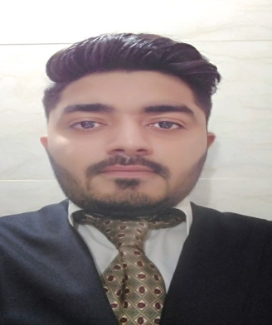 YASH

Email: yash.392399@2freemail.com
OBJECTIVE
Seeking a challenging position in the multi financial organization, which will provide ample opportunities to learn and grow, as well leverage my skills.

SKILLS
- Proficient in interpersonal, leadership and communication skills
- SME(Subject Matter Expert) in financial services & sales consulting.
- Strong strategic and analytical thinking & trading analysis
- Hands on experience in sales through MLM companies
- Hands on experience on MS office
- Quick learning with the ability to achieve organizational integration
- Excellent in building and maintaining healthy business relations with potential stakeholders & Recruit, train and mentor new & established financial advisors.

Core Competencies
~ Team Building ~ Business Development ~ Relationship Management ~ Leadership ~
~ Communication ~ Research and Development~

EDUCATION
- Bachelor of commerce (B.COM), Bundelkhand University, jhansi, 2015
- Higher Secondary Certificate, from kes College of commerce at Kandivali, Mumbai, 2012
- Secondary School Certificate, from PPHS INTERNATIONAL SCHOOL at Dahisar, Mumbai, 2010

ADDITIONAL QUALIFICATION

- NISM CERTIFICATION COURSE , ( MUTUAL FUND),(EQUITY DERIVATIVES) Mumbai, 2015

NATIONAL CADET CORPS (NCC), MUMBAI 2009-2012. )

PROFESSIONAL EXPERIENCE: 4 Years and 7 Months

Angel broking- Mumbai

Tradebulls Securities (P) limited- mumbai. (TEAM LEADER)

Stock Holding Corporation of India Ltd. (SHCIL).(TEAM LEADER)

Accountabilities:
- Managing a team of 15 Executives.
- Make work plan to ensure the quality services
- Ensure satisfaction of customers
6. Recruit, train and mentor new & established financial advisors.

PERSONAL DETAILS
Date of Birth: 5th March 1994
Hobbies: Travelling, playing multiple sports, Listening Music, meditation, follow educational program
References: Available on Request
Languages: English,hindi,Marathi,gujarati.

Visa status: visit visa

Validity of visa: 25 September

