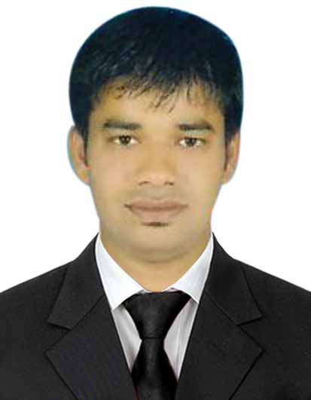
Suchin

Email: suchin.392420@2freemail.com

Career Objective:
To join in an organization which offers an opportunity to develop my skills and give my best efforts to the establishment. Where I can apply the knowledge and practical experience that I have gained in the various reputed Hospitality organization

Educational Qualifications:
- Completed my B.COM from ANDHRA UNIVERSITY , Vizag, INDIA 2010
- Completed my INTERMEDIATE from SRI VIJAYA SAI BODHAN [2007]
- Completed my S.S.C from SRI VIJAYA SAI BODHAN [2004]

Work Experience
- working as CASHIER from 2018 Dec till date
- Worked as CASHIER in GROUP FALACAK SERVICES (G4S) from 2017 to 2019
- Worked as CUSTOMER SERVICE EXECUTIVE in FOOD WORLD SUPER MARKET PVT.LTD from Sept. 2015 to August 2017 in Hyderabad, INDIA.
- Worked as SALES EXECUTIVE in ELEMENTS FENGSHUI from Feb 2014 to Aug 2015 in UAE
- Worked as Guest SERVICE EXECUTIVE in GREEN PARK HOTEL From 2011 TO 2014. In Hyderabad

Duties & Responsibilities:
- Welcome customer as they arrive with a smile
- Ask customer how they can be helped
- Provide customers with product information that they need
- Demonstrate the working of a product when the customer asks
- Provide customers with information on daily deals and promotions
- Ensure that all products are well stocked and are easy to reach.

Personal Skills:
- Working in a group with competitive spirits.
- Determination and Dedication towards the assigned works.
- Good understanding and cooperative

Personal Profile:
- Age : 29
- Nationality : Indian
- Birth Date : May 27, 1989
- Language Known : English, Hindi and Telugu
- Joining status : Immediately

