📧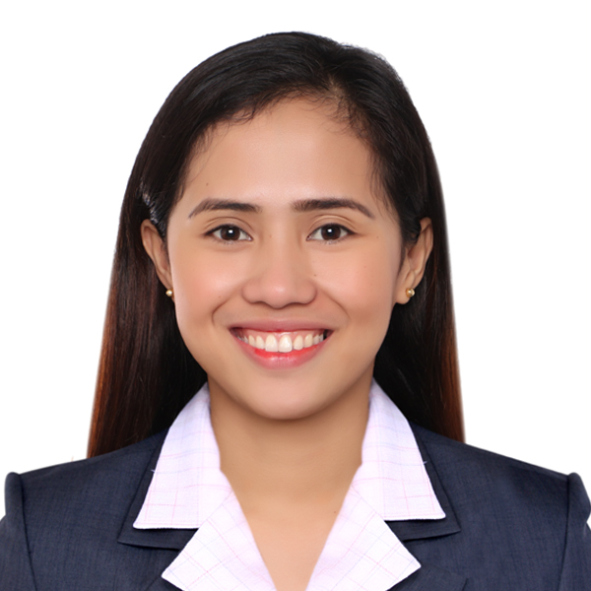

**SEMINARS/TRAININGS**

**Instructor**

2016-Present

**Science and Math Subject Head**

Senior High School Department, 2018-2019

**Research Coordinator**

Senior High School Department, 2018-2019

**Learners Information System (LIS) Coordinator**

Senior High School Department, 2018-2019

**College Instructor**

2018-2019

**Committee-SHS Days**

2018

**Module Editor (Inquiries, Investigation and Immersion)**

2018

**Class Adviser**

Senior High School Department, 2016-2018

**Senior High School Instructor**

Senior High School Department, 2016-2018

**Head Committee-Acquaintance Party**

Senior High School Department, 2017

**Module Writer (General Biology 2)**

2017

**Committee-Acquaintance Party**

2017

**WORK EXPERIENCE**

**ACHIEVEMENTS**

**PHINMA Araullo University**

Cum Laude, 2016

**PHINMA Araullo University**

Outstanding Student Teacher, 2016

**Classroom-Based (PHINMA AU)**

3rd Best Demonstrator, 2015

**PHINMA Araullo University**

Senior Tutor, 2015

**PHINMA Araullo University**

Junior Tutor, 2015

**Teach Like A Champion**

PHINMA Araullo University, 2019

**National Seminar Workshop Re-Calibrating Action Research**

University of the Philippines Diliman, 2018

**LIS and EBEIS Rollout for Public and Private Schools SY 18-19**

Department of Education-Cabanatuan City, 2018

**DepEd-PEAC 2018 Summer In-Service Training**

Holy Angel University, Pampanga, 2018

**Speaker– SHS Faculty Orientation SY 18-19**

PHINMA Araullo University, Cabanatuan City, 2018

I am highly motivated.

I can work with the best of my abilities in an under-pressure field.

Equipped with almost 3 years’ experience in teaching secondary and tertiary level.

Willing to work in a new environment and culture.

**STRENGTHS**

**Microsoft Office**

Intermediate

**Problem Solving and Analytical Skills**

Advance

**Interpersonal and Communication Skills**

Advance

**Leadership and Mentoring Skills**

Advance

**SKILLS**

References are available upon request.

**CHARACTER REFERENCE**

**PHINMA ARAULLO UNIVERSITY**

M.A. in Science Education (2017-Present)

**PHINMA ARAULLO UNIVERSITY**

Bachelor of Secondary Education-Biology,

Cum Laude (2012-2016)

**PALAYAN CITY NATIONAL HIGH SCHOOL**

Secondary Education (2008-2012)

**CAIMITO ELEMENTARY SCHOOL**

Elementary Education (2002-2008)

**EDUCATION**

Licensed Professional Teacher

December 2016

**PROFESSIONAL LICENSE**

I am a Licensed Professional Teacher and worked as a Senior High School (SHS) and College of Education (CoEd) Instructor in PHINMA Araullo University, for almost 3 years. Due to my performance, I became Senior High School Science and Math Subject Head and Research Coordinator. My strong initiative and exceptional organizational skills, combined with my ability to work well under pressure, allow me to play a crucial role in a fast-paced teaching environment.

**CAREER SUMMARY**

To optimize and diversify my knowledge and skills in a globally competitive work environment to foster self-growth and further organizational goal.

**OBJECTIVE**

[jeen.392442@2freemail.com](mailto:jeen.392442@2freemail.com)

**JEEN**