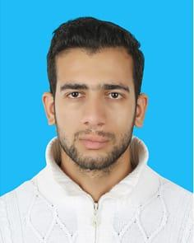
CURRICULAM VITAE

Ahmed

Health Serviece

Ahmed-392470@2freemail.com

Educational Qualification:

2014: Secondary General Certificate (Tawjehi) El-Motanabi Secondary School, Gaza Strip, Palestine.

2018: Health Management BCs – Al-Quds University - Personal Information:
Date of Birth | : 21 July 1995
Nationality | : Palestinian
Religion | : Muslim
Gender | : Male
Marital Status | : Single

Experience & Skills :

Skills
- First Aid Course .

- Microsoft office (Word,Excel and Power Point

- Ability to work under Pressure

- Ability to work in team

- Good Relation with the people

Experiences

- Volunteer on Gaza European Hospital 6 month .

- Work as Document controller for medical Records .

- Work as Secretariat

Languages Known:

- Arabic: Read, Write and Speak (Native Language).
- English: Read, Write and Speak (Medium Level ) .

