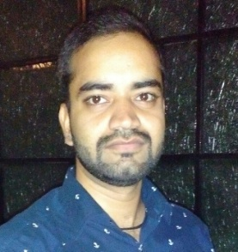
Resume
Arshad
Email Id: arshad-392479@2freemail.com

Being an individual with good communication and logical skills with zeal to learn; I want to infuseall my knowledge attained so far, for making the organization I work as an employee, a benchmark in the technical industry.

- EDUCATION

S.NO. | STANDARD | SCHOOL/  COLLEGE | BOARD/  UNIVERSITY | YEAR OF PASSING | PERCENTAGE/  CGPA
1. | B.Tech(CE) | Kautilya Institute of Technology& Engineering, Jaipur | RTU | 2017 | 63%(Aggregate)
2. | 12TH | Air Force School, Jaipur | CBSE | 2012 | 68%
3. | 10TH | Air Force School, Jaipur | CBSE | 2010 | 7.8 (CGPA)

- SKILLS
    - Good Communication skills.
    - Basic knowledge of computer networking
    - Languages: C, Java, MySQL

- STRENGTH
- Leadership and energetic
- Good communication skills
- Good motivator
- Good and quick learner
- Punctual

- TRAINING
- Texel consulting engineers, Jaipur from 21-05-2016 to 21-07-2016.

- PROJECT
Multistorey residential building(Foundation to top storey observation & analysis)
G+3 project at Raja park, jaipur( Currently working)

Work experience is of 1 year.

- HOBBIES
- Playing basketball and chess
- Gymming and occasional run

- PERSONAL PROFILE:
- Date of birth : 17th April 1994
- Languages known : English, Urdu& Hindi

I hereby declare that all the above-mentioned information is true to the best of my knowledge and belief.

