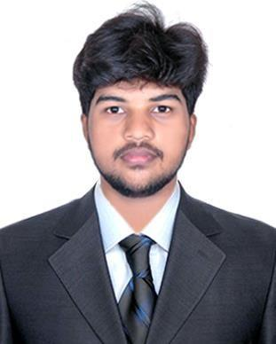
Rashith
Rashith-392482@2freemail.com

OBJECTIVE:-

Intend to build a career with leading corporate of hi-tech environment with committed & dedicated people, which will help me to explore myself fully and realize my potential. Willing to work as a key player in challenging & creative environment.

EDUCATIONAL QUALIFICATION:-

- Passed in Secondary school Leaving certificate in Swami Vivekananda higher secondary school, Nallelundhur with 83% of Marks during the period of 2014-2015.

- Studied Higher secondary certificate in Thandhai Periyar Hr. Sec School – Karaikal with 48% of Marks during the period of 2015-2017.

SKILLS:-

OPERATING SYSTEMS EXPOSURE

: Windows 98/2000/XP/vista/7/10.

: Typewriter, MS-Office.

PROFESSIONAL SKILLS:-

*Time Management

*Communication

*Calendar Keeping

*Leadership

*Record Keeping

*Self-motivation

* File maintenance

*Decision making

ADDITIONAL COURSE:-

- Tally ERP 9

EXPERIENCE (2 years):-

- Worked as Quality control in Wonjin autoparts pvt ltd at chennai.

  - Managed the quality of products and inspected for production parts.

  - Handled project launches and worked to solve manufacturing challenges.

PERSONNEL PROFILE:-

DOB

Nationality

Languages Known

Marital status

Visa Status

Visa Expiry

: 13.08.1999

: Indian

: Tamil, English

: Single

: Visit Visa

: 02 -09- 2019

ADDITIONAL INFORMATION:-

PERSONAL OVERVIEW:

Hardworking, Flexible, Learning oriented, Committed & possess a strong determination to endeavour any task assigned.

MY STRENGTHS:-

- Young and Dynamic.

- Easy and clear way of expression.

- Innovative in my profession.

