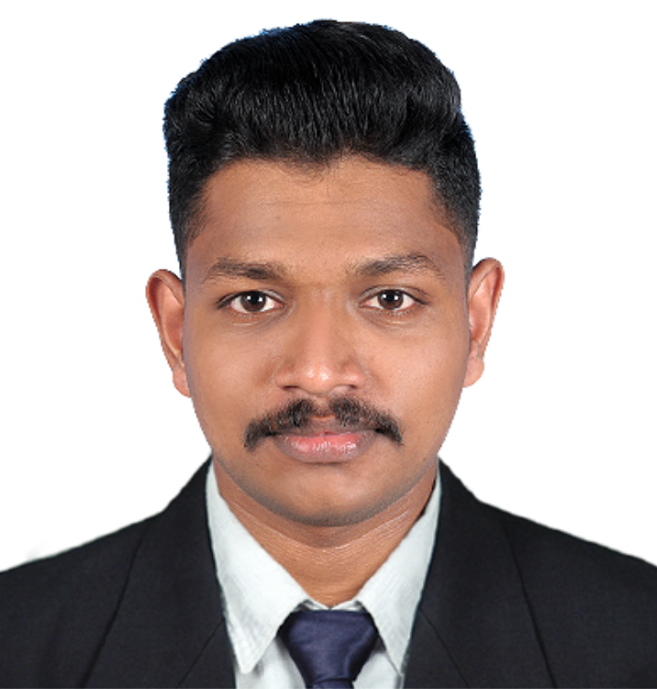
RESUME
LIJO
Lijo-392499@2freemail.com

CAREER OBJECTIVE:
Seeking a challenging and rewarding opportunity in production, manufacturing, construction or design with an organization where I can contribute my knowledge and skills to organisation and enhance my experience through continuous learning and teamwork with hardworking and goal- oriented with a high degree of flexibility, creativity, resourcefulness, commitment and optimism.
EDUCATIONAL QUALIFICATIONS:
- DIPLOMA IN MECHANICAL ENGINEERING
First class with distinction (Percentage 89.3%)
Sree Krishna polytechnic collage, Nagercoil, Tamil Nadu
AICTE affiliated
Year of passing: 2013-2016
- Vocational Higher Secondary Education
With First Class (Percentage 70%)
Board of Examination: Kerala State General Board of Examination
SVMMVHSS Vendar , Kerala.
Year of passing: 2011-2013

- Secondary Education (SSLC)
With First Class (Percentage 72%)
Board of Examination: Kerala State Board of Higher Secondary Examination
Govt.Higher secondary school, puthoor, Kerala.
Year of passing: 2010-2011
TECHNICAL QUALIFICATIONS:
- QA/QC (Total Quality Management)
- QC in Welding Inspection (under Scientific and Technical Education Development (STED) Council).
- Piping & Pipeline Engineering (under Scientific and Technical Education Development (STED) Council).
- Nondestructive Testing(NDT)
(American Society for Nondestructive Testing (ASNT) Level II)
          - Radiography Test
          - Ultrasonic Test
          - Magnetic Particle Test
          - Liquid Penetrant Test
          - Visual Inspection
From AIRON ACADEMY, Pathanamthitta.
PROJECT:
As part of academic curriculum
Project : FABRICATION OF TURBO CHARGER FOR TWO WHEELER
Review : An attempt has been made in this project; the exhaust gas is used to rotate the turbine with blower arrangement. Exhaust gas is used to rotate the blower and this air is given to the ignition input supply. Our fore most aim in selecting this project is to use efficiency turbo charging. It is also good with regard to economical considerations and engine efficiency.
SKILLS:
- AutoCAD
- PIPING & PIPELINE DESIGN
- MAINTENANCE OF COMPRESSORS AND PUMP
- CREO

EXTRA-CURRICULAR ACTIVITIES:
- Core Committee member for cultural activities in College.
- Participated and won quiz competitions in college
- Participated and won various cultural competitions in school and college level.

PROFESSIONAL EXPERIENCE :

- Worked as Technician Apprentice in Vikram Sarabhai Space Centre (VSSC), ISRO, Thiruvananthapuram from October 2016 to October 2017

- Worked as piping superviser in condensate polishing unit in 2x500 NNTPP NEYVELI

PERSONAL DETAILS:
- Place of Birth : Kerala
- Date of birth : 10/12/1995
- Nationality : Indian
- Languages known : English ,Hindi, Tamil, Malayalam
- Hobbies : Listening music, Reading, playing cricket and football

