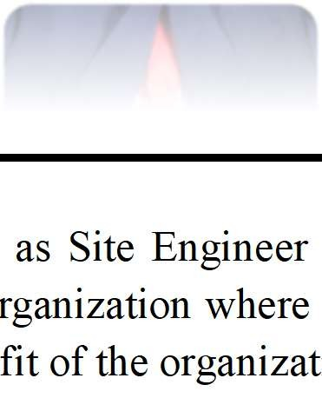Resume

PRAVEEN

praveen-392541@2freemail.com

PROFILE SNAPSHOT:

A Qualified Civil Engineer with 4+ years of experience seeking a responsible position within the organization and to work for an or my skills, creativity and knowledge can be utilized for maximizing the benef ion.
as Site Engineer ganization where
it of the organizat

EXPERIENCE SUMMARY:

3 year in GCC as Site Engineer.
- 1 year in India as Site Engineer.

EDUCATIONAL QUALIFICATIONS:

Qualification | Institute | University/ Board | Year | Grade
B.E  (Civil Engineering) | Mepco Schlenk Engineering College, Sivakasi  TamilNadu. | Anna University, Chennai,  Tamil Nadu. | 2011- 2015 | First class

PROFESSIONAL EXPERIENCE:

- Project : Lusail Plaza Infrastructure, LRT Station, Public car park a Landscape
nd

rpark and
Duration : April 2016 to Present. Company : QD-SBG Construction Position : Site Engineer.

Work platform:
  - Construction of Foundation, Tunnel, Underground ca substation.
  - Repair and Rehabilitation works for concrete.
  - Monitoring Waterproofing works (Subcontractor)
  - Monitoring Crack injection (subcontractor)

P a g e 1 | 4

Resume

Project Overview
CLIENT/OWNER MASTER DEVELOPER CONCEPT DESIGNER
PMCM
CONSULTANT CONTRACT TYPE LAND AREA
TOTAL BUILT-UP AREA
LOCATION

Qatari Diar Real Estate Investment Company
Lusail Real Estate Development Company
Worley-Parsons
Parsons
Dorsch
Lump Sum, D&B
420,000 m2
151,198 m2
Lusail City

RESPONSIBILITIES IN QDSBG:

- To Assist Project / Construction Manager in the Supervision and management of construction Activities to assigned project
- Conduct daily briefing with site team leaders to Follow-up and report on the work progress in Order to anticipate any possible delays with Regards to planned tasks.
- Take immediate corrective action to avoid any cumulative effect of such deviation and recover the delay to finish the task in due time.
- Assist in planning and sequencing of the construction operations according the Project Quality Plan.
- Ensure awareness of safety & Compliance with HSE rules and regulations by subordinates and contractors.
- Conduct regular inspections and assess the work performance done by all subcontractors.
- Evaluate and resolve any discrepancies and problems arising during construction which affect the quality of works performed.
- Attend meetings with required concerns to solve technical issues and other related matters on sub-contracts for discussing obstacles and progress of works.
- Coordinate/liaising with the handing over of completed works to client/subcontractors and completion of the necessary rectification works.
- Inspects and prepare list for completion of works done by sub-contractors after acceptance inspection by consultant.
- Provide Technical Support to other team members.
- Establish, report and follow up all on non-conformance activities
- Ensure projects meet the agreed specifications, budgets or timescales
- Prepare and initiates site inspections with consultant in accordance with QC.

P a g e 2 | 4

Resume

- Prepare site work orders for extra works done by sub-contractors which in not included in contract
- Checking and preparing site reports, designs and drawings, planning schedule for execution of site activities.

- Project : Improvements to the Interior BT Roads in Chennai Corporation.
Duration : Jan-2016 to April-2016.
Company : CMEC_Megastar JV
Position : Site Engineer and Assistant Quantity Surveyor.

RESPONSIBILITIES IN CMEC_MEGASTAR:

- Planning, Scheduling, Rescheduling, Allocating Resources, Cost analysis and maintaining the progress report daily.
- Maintaining and allocating resources both Materials and Labors for work
- Maintaining Gantt chart, which can show different between Scheduled date and
- Actual date of work.
- Maintaining Work Calendar, Time Sheet as per work schedule.
- Preparing Monthly Progress Report
- Preparing measurement Sheets and Quantity analysis.
- Preparing detailed report of the project day-by-day, week and monthly Report as well maintaining the whole project as scheduled.
- Maintaining Site as given in BOQ.
- Co-ordinate workers in site and maintain proper construction as per diagram and requirement of site.
- Check and work with proper safety management.

- Project : Construction of Residential building.
Duration : May-2015 to Dec-2015. Company : Anbazhagan Construction. Position : Site Engineer.

RESPONSIBILITIES IN AZN CONSTRUCTION

- Daily report and checking work for standard.
- Proper material stocking.
- Drafting off building plans.
- Valuation of Building materials.

P a g e 3 | 4

Resume

SOFT SKILLS

Microsoft Excel | Expert
AUTOCAD | Intermediate
Microsoft , Primavera | Basic Knowledge

CERTIFICATES:

AutoCAD
Issued by: Autodesk Issued on: 2013-2-21

PERSONAL PROFILE:

Date of Birth : 17.06.1994.
Gender : Male.
Marital Status : Single.
Language Known : Tamil, English, Hindi.
Nationality : Indian.
Visa Status : Visit visa.

P a g e 4 | 4

