JABIR
 Jabir-392604@2freemail.com

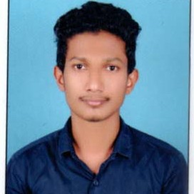


Secure a challenging position in Accounting with a reputed organization where my education & experience will be utilized for mutual beneﬁt.


Control over all Accounting and Financial matters
Preparation of bank reconcilation statement
Preparation of year ending schedules and accounts for audit. All kinds of Bank Transactions.
Maintaining purchase & sales including stock register. Maintaining payroll
Check and verify all payments and receipts
Co-operating with the team members to achieve target

Experience

Jamia Sa-adiya Arabiya
-
Accountant cum Oﬃce Executive One year in Kasaragod
Indus Motors
-
Cashier cum Assistant Accountant One year in Kanhangad



2018
Bachelor of Business Managment
2012
Higher Secondery Education
2010
SSLC
2014
Completed a course entitled CACFA(Certiﬁed Accountant in Computerized Financial Accounting)

COMPUTER LITERACY

Advanced knowledge of accounting package Tally, PEACHTREE, QUICKBOOK, WINGS. Proﬁciency knowledge in Computer.

Skills

Flexible and Adaptable
Leadership Qualities Passionate for Work Aggressive
Vision for Achieving Goals

Language

Speak- Malayalam , English
Read - Malayalam , English , Hindi ,Arabic Write - Malayalam , English , Hindi, Arabic

 | Personal Data
 | Date of birth  Sex | : 12/07/1994  : Male
 | Religion | : Muslim
 | Nationality | : Indian

