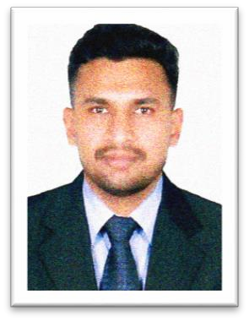
Curriculum Vitae

AL AMEEN
alameens-392767@2freemail.com

SUMMARY
- A well-qualified professional with 3 years of experience in UAE Dubai in a reputed firm ‘Emirates Group, Transguard LLC.
- Started the Carrier as a Security Officer and then been promoted to the level as a Patrolling Supervisor in Jumeirah Golf Estates on behalves of Transguard Group LLC.
- Experienced in various fields like Sales, Marketing, and BPO’s in India.
- A Graduate in Commerce and Management studies from a reputed University and a Valid UAE Driving License Holder (Manual).

ACADEMIC QUALIFICATION
- B. Com Commerce with Tourism and Travel Management (Kerala University, India) Awaiting for Final Results.
- Intermediate in Commerce and Accounts.
- Matriculation in General.

COMPUTER SKILLS
- MS Office.
- Galileo Computerized Reservation System (CRS)

PROFESSIONAL EXPERIENCE
- Currently working as Patrolling Supervisor in Jumeirah Golf Estates on behalves of Emirates Group, Transguard LLC. Since 2016 till the date.
- Worked as a Sales Executive in a Smartphone retail shop in India from 2013 to 2016.

PERSONAL INFORMATION
Date of Birth: 03-01-1995
Marital status: Single
Nationality: Indian
Religion: Islam, Muslim
Languages known: English, Hindi, Malayalam, Tamil
Visa status: Residence (Free zone)

