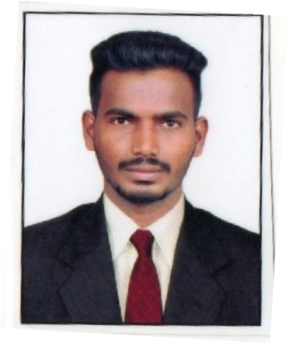
CURRICULUM VITAE

VENKATESH

Civil Draughtsman

venkatesh-392796@2freemail.com

CAREER OBJECTIVE
To join a highly professional and dynamic organization where, I can utilize my best drafting knowledge and vast work experience to grab ample of career progression opportunities.

ACADEMIC QUALIFICATION

- Princeton College of Engg, & Tech ,Ghatkesar, Hyderabad, telangana, Postal Code: 501301 India.

- Diploma in Civil Draughtsmanship Nazzrfin Computer Education Jagtial, Karimnagar, telangana,India ,Passed on Sep 2017.

- Sharada Vidyanilayam High School Jagtial, Karimnagar, telangana, Postal Code: 505327 India, Passed on Sep 2011.

KEY SKILLS

  - Relevant educational credential.
  - Advanced proficiency in the latest version of AutoCAD, Microsoft Office, Windows and application.
  - Having the ability to visualize finished products as well as projects.
  - Experience In preparing CAD drawings.
  - Good knowledge of construction and design principles
  - Good Analytical ,Design and development skills
  - Having good planning and problem solving skills
  - Confident and Consistent in producing results.

WORK EXPERIENCE
More than 1 years of working experience in K.AJAYKUMAR Contractor, karimnagar

WORK HANDLED

Preparation of Setting out Plan
- Preparation of Various type of sections and detailed drawings.
- N.O.C.s’ Drawings for Municipality.
- Preparation of site progress report.

Computer and Software skills.
  - Knowledge in Auto CAD 2017 and older version.
  - Knowledge in Autocad Civil 3D.
  - Knowledge in Microsoft Office packages.
  - Knowledge in Photoshop.

PERSONAL DETAILS

Date of birth : 30 – 11 – 1994 Sex : Male
Marital status : Single
Nationality : Indian

