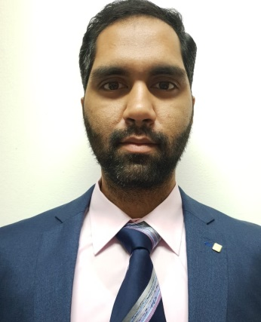
Abdul
Email: Abdul-392821@2freemail.com
Visit visa (up to 20th September, 2019)
Work Experience
- Assistant Procurement Manager
Lahore, Pakistan (08/2018 – 03/2019).
Educational Background
- Bachelor of Arts (Hons) Logistics Management
Limkoking University (LUCT)
Kuala Lumpur, Malaysia (2018).

- Cost & Managerial Accountant (CMA Stage-1)
Institute of Cost & Managerial Accountants of Pakistan
Lahore, Pakistan (2012).

- Bachelor of Commerce (B.Com)
Punjab College of Commerce
Fasilabed, Pakistan(2011).

- Higher Secondary Certificate (HSSC: KG1 – Grade-12)
Shaikh Khalifa Bin Zaid Arab Pakistani School
Abu Dhabi, UAE (2008).
Courses Studied:
Budgeting, Forecasting & Cost Reduction, Customer/Supplier Relationship, Marketing & Sales, I.T. (MS Office), International Trade, Inventory, Stock/Storage Planning & Material Handling, Operational Logistics Management,
Packaging Handling, Procurement Analysis & Process Improvement, Project Based Logistics, Project Management, Strategic Planning & Business Integration,
Supplier / Vendor Database Management, Supply Chain Management & Solutions
Supply Chain, Transportation & Cargo Management, Warehouse/Storage Management.
Abdul
Email: Abdul-392821@2freemail.com
Visit visa (up to 20th September, 2019)
Personal Skills
Communication, Interpersonal & Management Skills
Customer Supportive & Flexible
Decision-Making & Scheduling Capabilities
Decisive, Proactive & Assertive
Details & Result Orientated
Organizational & Time Management Skills
Problem-Solving & Process Improvement
Good Team Leader / Member.

Computer Skills
Microsoft Office : Excel, Word, Powerpoint.

Personal Information
Date of Birth : 11th April 1990 (29 Years)
Nationality : Pakistanies (By Birth)
Social Status : Single
Gender : Male
Religion : Muslim (Sunni)
Languages : English, Urdu (Read, Write, Speak)

Reference
Will be provided upon request.

