B  CURRICULAM VITAE – BENAZIR  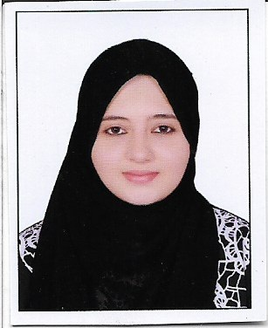  Email:  Benazir-392838@2freemail.com  My Performa  DOB : 20/08/1992  Sex : Female  Nationality : Indian  Religion : Muslim  Marital Status : Married  Languages : English, Urdu,  Hindi. | Career Objective:  Committed School Teacher providing comprehensive supervision and support to students. Adept at creating an atmosphere conducive to learning while ensuring that the required curriculum is applied. Specialize in efficiently utilizing learning assets to foster a positive productive learning environment through astute observation and engagement.  Education qualification  - Bachelor of Education with Grade ‘A’ - 2017  Mumbai University, Maharashtra State (India).  - Master of Commerce with Grade ‘B’ - 2014  Mumbai University, Maharashtra State (India).  - Bachelor of Commerce with First class - 2012  (Special- Financial Accounting and Auditing)  Mumbai University, Maharashtra State (India).  - Higher Secondary Education with Grade ‘B’ - 2009  ( Commerce faculty)  Maharashtra state Board, Pune (India)  - Secondary Education with Grade ‘B’ - 2007  Maharashtra state Board, Pune (India)  Academic Work Experience  Worked at M.I. Hajwani English Medium School, Al Madina Welfare Associations as Asst. Teacher for Grade 1 to Grade 5 from June 2014 to April 2018.  Role & Responsibilities;  - Plan, manage and deploy the curriculum within the guidelines of school policy.  - Arrange, decorate and maintain appearance of classroom.  - Modify lessons and materials to meet student and classroom needs, adjusting to student’s level of progress.  - Set expectations for class with focus on positive learning environment.  - Enforce school policies and procedures with both students and parents.  - Assess student progress and communicate status with principals and parents.  - Submit weekly lesson plans to principal for review and authorization.  - Participate in school events such as orientations, programs and open houses.  - Attend summer teaching and training conferences and workshops.  - Work with staff and colleagues to provide support for the goals and models of the grade school.  Personal Profile  - Dedicated and student-focused teaching professional committed to provide a well-balanced, supportive, and engaging learning environment for all students.  - Aptitude to remain flexible, ensuring that every child’s learning style and abilities are addressed.  - Hardworking and trusted educator who strives to collaborate with all members of school community to meet the needs of students and promote the philosophy of the school.

