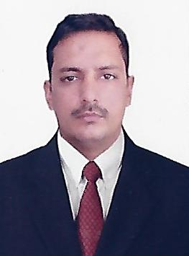
Idrees

Email: idrees-392843@2freemail.com

OBJECTIVE:
My objective behind applying for a job is to obtain a responsible position in a professional corporate environment where I can grow personally and professionally.

PROFILES
- Strong interpersonal and communication skills
- Hard working and dedicated
- Can work under pressure with time bound performance
- Easy adaptability to situations

EDUCATION QUALIFICATION
- Metric from Pakistan
- Diploma of Associate Engineer from Punjab Board of Technical Education Lahore Pakistan for 3 Years
- Bachelor of Technology (B-tech) in Electrical Technology from Preston University for 4 Years

WORK EXPERIENCE
- Worked as anElectrical Engineer in Malaysia for 4 years– 2014 to 2018
Duties and Resposibilities:
  - Planning and organizing
  - Working knowledge of Microsoft Office
  - Implements and enforces work rules
  - Inspect fieldwork to evaluate construction progress, efficiency of operation cost control. Responsible for overall project workmanship and goal attainment.
  - Overseas the daily construction activities at work site, including scheduling of workers, delivery of equipment’s and materials and progress of the project.
  - Responsible for work procedures, scheduling, cost control, project specification conformity, establishment of manpower levels, monitoring and implementation of safety programs, project conformance to national, local and company building codes and the maintenance of accurate records.
  - Implements procedures to ensure construction operations are continuously adhering to engineering designs, specifications, quality standards schedules and budget.

- Worked as Electrical Supervisor in Faisalabad Pakistan for 3yaers
2011-2014
Duties and Resposibilities:
  - Supervising and undertaking electrical works within a commercial environment
  - Overseeing the complete strip out and refurb of a client site.
  - Dealing with any technical issues that may arise.
  - Carrying out servicing and pre-planned maintenance electrical task.
  - Ensuring that on site Health & Safety regulations are strictly adhered to.
  - Supervising the work of junior and newly qualified personnel.
  - Conducting site surveys, audits and inspections.
  - Organizing work schedule and maintaining workers timesheets.
  - Undertaking hands on electrical installation work.
  - Making sure that safe working practices are maintained at all times.
  - Making sure that work method are sufficient to meet a project needs.

PERSONAL INFORMATION
Date of Birth : 10-04-1988
Nationality : Pakistan
Sex : Male
Marital Status : Single
Languages Known : English, Hindi, Malaya& Urdu
DECLARATION
I hereby declare that the particulars furnished above are true to the best of my knowledge and belie.
Idrees

