JIBIN
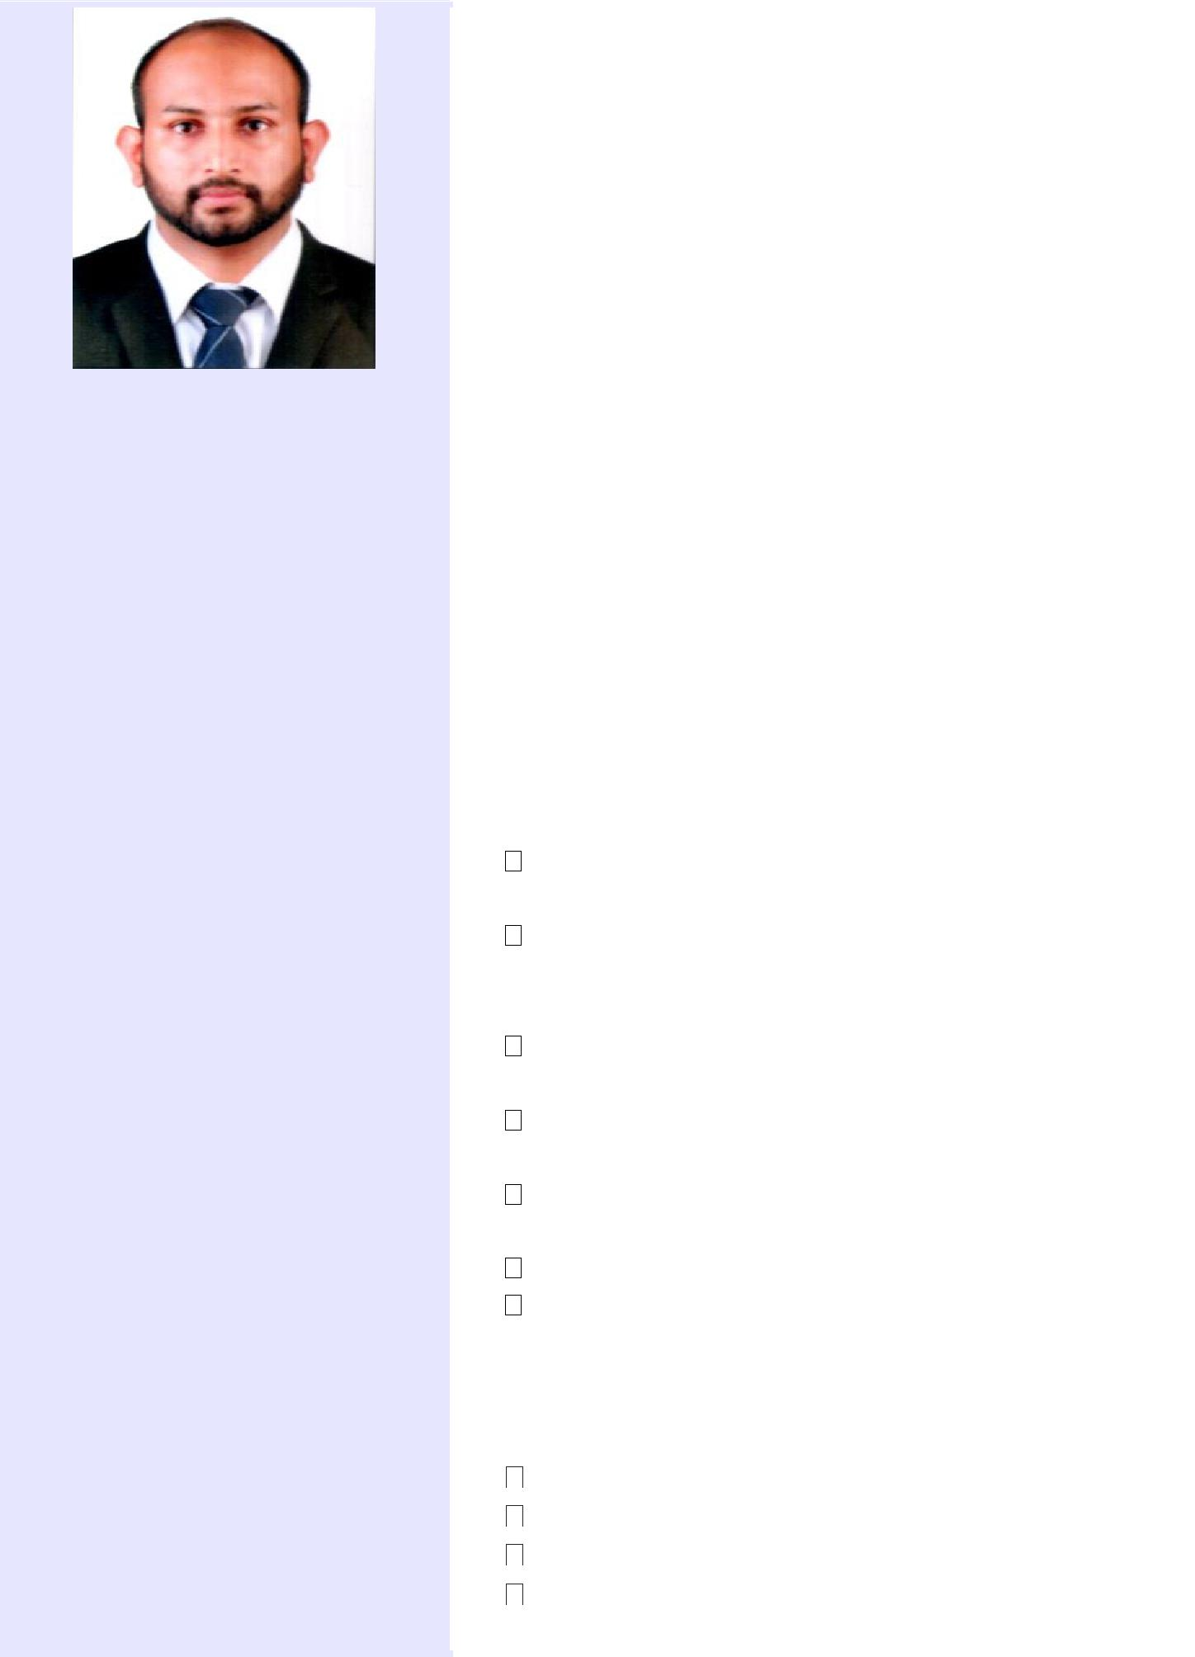

Email :
Jibin-392859@2freemail.com

Personal Data :
Age : 28

DOB : 13-03-1991

Sex : Male

Nationality : Indian

Marital status : Married

Valid UAE Driving License:

Yes

Career Objective :

To be associates with an organization that provides the most challenging and interesting career opportunities and to apply my knowledge and skills for the organizational growth.

Personal Statement :

I am a Mechanical Engineer, with two year experience as Procurement & Sales Engineer in Dubai. Aiming to foster and furnish my strengths and use the same for the varying trends of the highly competitive industry.

Employment History :

Magnatech Middle East Trading LLC

Procurement & Sales Engineer

Dubai, UAE

April,2017 – April,2019

Strong ability to source right material as per the requirement.

Achieve the highest level of order fulfilment activity to the utmost satisfaction of customers and sales team.

To send quotation for the inquiries, sourcing and arranging delivery for the Tools division.

Maintain good relationship with existing suppliers and grow supplier base.

Work under least supervision and manage local purchase of equipment & parts efficiently.

Plan and execute efficient material deliveries. Resolve conflicts internal & external, supervise transport Team.

Professional Skills :

SolidWorks Basics

AutoCAD 2D

Ansys CFD

MS Office Suite (Word, Excel and

PowerPoint)

Educational Qualification :

- S S L C : Kerala State Board

- Plus Two : Science [Board Of Higher Secondary Examination]

- Degree : B Tech in Mechanical Engineering [Mahatma Gandhi University]

- Post-Graduation : M Tech in CAD/CAM [VIT University, Chennai campus]

Additional Qualification :

Completed Heat Ventilation and Air Conditioning (HVAC) Designing and Drafting course from Aghora Infrastructure Pvt. Ltd.

Achievements :

- Active participation in extracurricular activities in School and College level.

- Served as the Student head of technical coordination committee in conducting

“Project Exhibition” for Mechanical technical fest MECHNIUS-2012.

- Winner in marathon race conducted at college level.

- Member of college football team and won intercollege football tournament in 2011.

- Individual champion at school level athletic meet.

Strengths :

- Ability to work in new and challenging , as well as deadlines driven environment .

- Willingness to work in groups and ability to lead group activities .

- Willingness to learn new concepts and ideas involving new technologies with an ability to adapt quickly and implement effectively .

Languages Known :

English , Malayalam, Hindi (Read , Write & Speak )

Declaration :

I hereby declare that all the details mentioned above are true to my knowledge.

Place: Dubai

JIBIN

