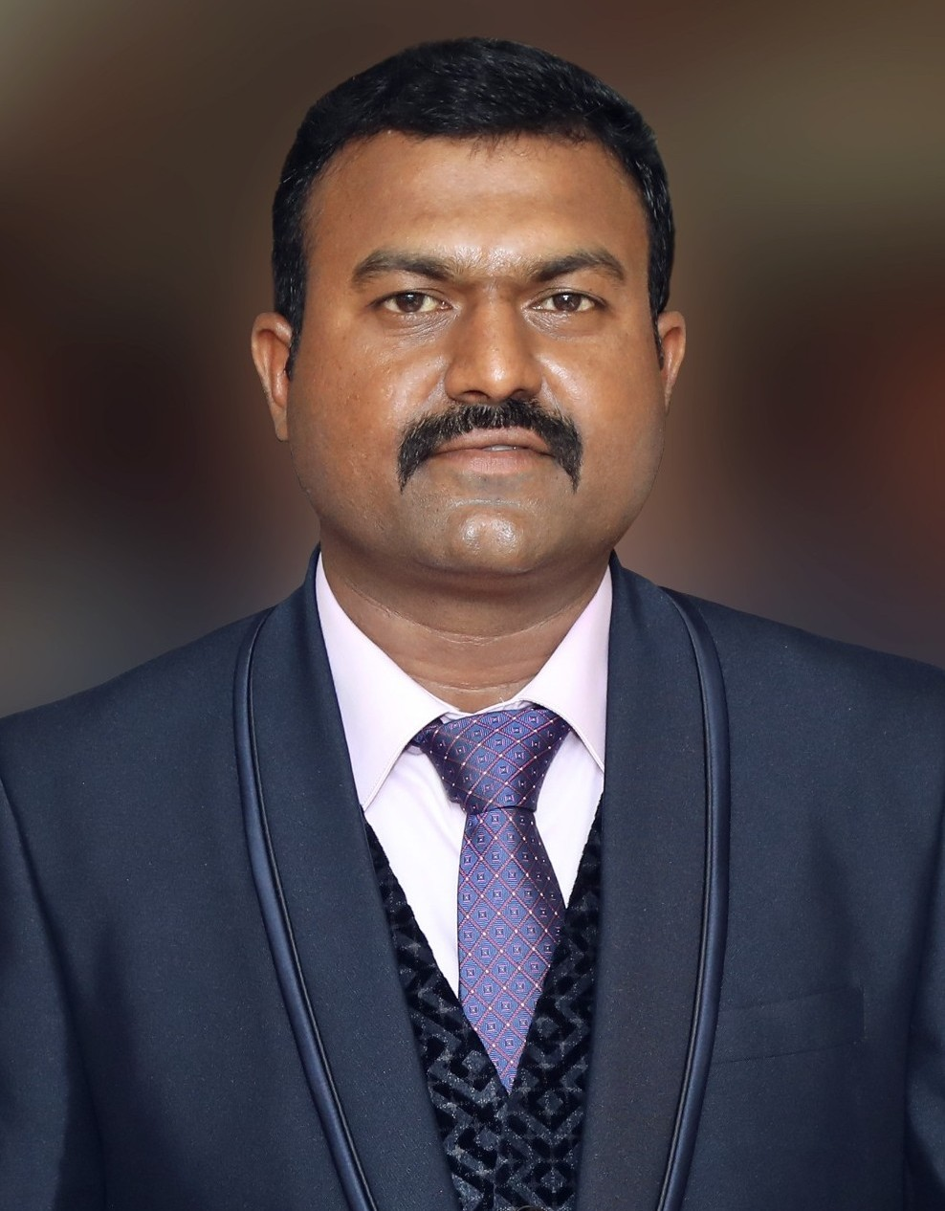
RICHARD.X

richard-392863@2freemail.com

Summary:
- A result-orented professional with over 12 years career in information technology.
- Highly skilled ERP Specialist in application development & enhancement, software testing & implementation in production and manufacturing industries. Has strong knowledge in multiple platforms including SAP ECC 6.0.
- Skilled in systems, network and security devices installations and maintenance. Troubleshooting issues to identify root causes and prevent recurrence.
- Seeking a challenging position in a company that is rapidly expanding where I can apply the knowledge I have earned this while and contribute it to the success of the organization.

Skill Set:
ERP : SAP ERP 6.0 Implemented and maintained
Languages : Java , ABAP/4
Databases : Oracle 11i, IBM DB2
Windows Servers : Windows 2003, 2008 DHCP, Local Security Policies, Active
Directory, Users and Groups
Network Security : Fortigate 110 C Firewall, Trend micro Inter scan Messaging
Security Suite 5.5, Netfox Firewall, VPN, MPLS and RF

Professional Experience:

Having 8 Years of Experience as a Information Technology Specialist in VKS Foods Pvt Ltd, Tamilnadu from Sep 2010 to June 2019

- I involved in setting up SAP ECC 6.0 implementation in 3 system landscape with Redhat Linux
- Major Role in Hybrid Network Datacenter Establishment and Maintenance.
- SAP ECC 6.0 EHP4 Implemented and maintained, as a core user involved PP&QM, MM and SD Modules implementation.
- SAP R/3 ABAP/4 Programmer with MM, SD and PP Modules.
- Comprehensive experience with SAP Profile Generator with strong skills related to the Authorization Concepts using the TCODE PFCG
- Performed user administration activities such as setting up user login Ids and assigning and resetting passwords, locking and unlocking users.
- Provide technical support for post-implementation of SAP R/3. The work includes develop- ment and fine-tuning of reports, performance trace and evaluation.

- Creation of interactive and classical reports, development of reports using SAP List viewer (ALV)
- Work involved in creation and modification of new and existing reports based on user’s re- quirement.
- Time based and event based Scheduling of background jobs and monitoring.
- Interaction with ERP team for Implementation and commercials
- Feasibility and Requirement Study for Wan connectivity throughout India
- System / Connectivity Hardware Requirements study and Procurement for our Group
- WAN – Connectivity & Bandwidth monitoring and Performance Tuning
- Fortigate Firewall Installation & Configuring nodes, objects, Polices and services
- Implementing Fortigate IPSec VPN Clients in all Branches.
- Network structure designing & Maintenance
- Maintaining around 19 locations ( MPLS: 11, VPN: 8)

Having 5 Years of Experience as a ERP Support Engineer in AMARJOTHI GROUPS, Tamilnadu from April 2005 to Aug 2010
- Coordinated with developers and system engineers to fix application defects
- Analyzed system requirements and document entire software testing process accordingly
- Responsible for maintaining updated reports on resolved bugs
- Analyze test specifications and perform manual testing
- Collection and Maintaining Data of different location and uploading into the system and preparing report as per management requirements.
- Wrote SQL queries and constructed administrative ages for web-based reporting.
- Product implementation on Test Server and Live Server
- Working closely with the users, examine existing business models and the flow of data in the business
- Data Manipulation and generating customized reports according to requirement.
- Master Data collection, data cleansing and data uploading
- User Training and ERP testing with real data
- After Go Live support and trouble shooting
- Documented the all processes currently in use and verified the existing work flows with all Departments
- The Other Main responsibilities included was data backup, Data restoring and maintenance and performance tuning etc.

- Writing user manuals and providing training to users of the new system Business Ap- proach
- In post Implementation mainly worked upon generating MIS reports

Project Name | Enviroment | Description
Yarn Cost Estimation | Java, JSP, Servlets and Oracle | Estimate the Cost for the yarn and Generat-  ing order booking from clients
Raw Material System | Java, RMI, Swings, Servlet , Oracle10i, Tomcat Server | Raw Material inward, stock maintain with different kind of reports, material weight details captured with weighing  machine interface and barcode scanner
HRD Monitoring System | Java, JSP, Servlets and Oracle. | This is a 3-tier application to maintain the complete processes of Employee Details, At- tendance Maintenance, Shift Allocation, Salary Allocation etc using biometric sys-  tem.
WAN Internal Mail | Java, JSP and Tomcat Server | This System deals with the Sending Internal  Mails, Reports and Letters.

Having 1 Year Experience as a Software Implementation Executive in TBS Technologies, Tamilnadu from May 2004 to Mar 2005
- Work closely with other software engineers, QA and Support groups as well as Retail Busi- ness and Operations groups to develop top quality products that solve actual business And technology problems.
- Implemented enhancements and new modules to the existing system.
- Create new work flows for different business process
- Installing, configuring servers, routers, switches as per client requirement.
- Setup and maintain Internet connections.
- Travel to client sites across the country and deploy the software.

Academic Qualification:
- Masters in Computer Science – 2009 (Bharathiyar University, 64%)
- Bachelor in Computer Science – 2004 (Vidhyasagar College, 65%)

Personal Details:
Date of Birth : 09.06.1984
Languages Known : Tamil & English Marital Status : Married

