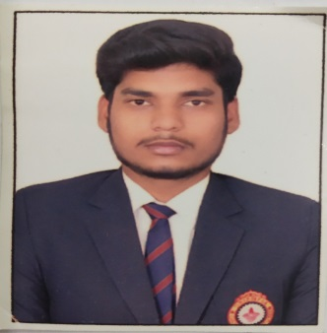
RAJAT

Rajat-392896@2freemail.com

Career Objective:

To work for an organization which provides me the opportunity to improve my skills and knowledge to growth along with the organization objective.

Academic Credentials:

Year | Education | University | Percentage
2015-2019 | B.Tech(Information Technology) | R.G.P.V (India) | 6.59 CGPA
2015 | Senior Secondary(XII) | C.B.S.E (India) | 69.40%
2013 | High School(X) | C.B.S.E (India) | 7.8 CGPA

Project & Training:

- Training on Web Designing at CNC WEBWORLD, Pune(June 2018 – July2018).
- Project undertaken: Website designing.
- Technologies & languages used : HTML, HTML 5.0,CSS3, CSS, JAVASCRIPT

Technical Skills:

● Languages: C++, HTML, CSS, basics of PHP,MYSQL,Python
● Field of Interest: WEB DESIGNING, DATABASE MANAGEMENT SYSTEM.
● Softwares Used: DEV C++, NOTEPAD++, CORELDRAW, ADOBE PHOTOSHOP, MICROSOFT OFFICE, ATOM.

Key Skills:

● Leadership
● Quick learner and dedicated to work
● Management and Organizational skills

Extra-Curricular Skills:

Institute | Event | Role | Year
OIST | Tech-Achme | Coordinator(BADMINTON) | Feb-18
OIST | Tech-Achme | Volunteer(ROADIES) | Nov-17

● Participated in national and international level competition like “Math’s Olympiad” and “Science Olympiad”

Personal Details:

- D.O.B: 01-10-1997
- Religion:Hindu
- Marital Status: Single
- Language: English,Hindi

