CURRICULUM VITAE

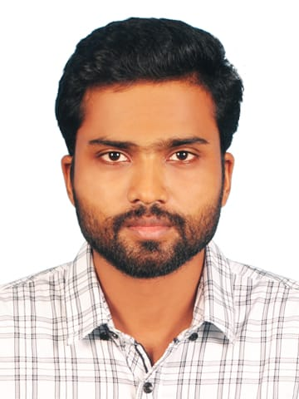

MUHAMMED
EmailID : muhammed-39293@2freemail.com
OBJECTIVE
To work in challenging environment and to be a part of a team involving myself giving the expected result and in addition to contribute toward the growth of the organization through new ideas and skills.
PROFILE:

- Preparing Financial Documents such as invoice, bills and accounts payable andreceivable.
- Completing the purchaseorder.
- Scan goods and ensure pricing is accurate.
- Stock shelves following the supermarket’s policies and make sure that any out of stock product is informed to the supervisor.
- Maintain the company ledger and cashbooks.
- Coordinating internal and externalaudit.
- Managing day to daytransaction
- Posting dailyreceptors
Qualification:

- Prof. Diploma in Network Engineering at KELTRON (A Gov. of Kerala Undertaking). (2014)
- Diploma in Tally Accounting at cyber computerkollam, kerala. (2014)
- Bachelor Degree in science at T.K.M College of arts & science, kollam, kerala. (2013)
- XIIth (HSE) Course in Science at ST. Aloysius H.S.S, Kollam,Kerala. (2010)
- SSLC at ST. Aloysius H.S.S, Kollam, kerala. (2008)
Work Experience :
- Computer Operator at Kollam, Kerala (May 2015 – Nov2016)
- Sales man at Kollam, Kerala (Jan 2017 – Aug 2017)
- Cashier at Kollam, Kerala (Jan 2018 – June 2019)
PERSONAL PROFILE:
- Date ofBirth : 30-11-1990
- VisaType : Visit
- Nationality : Indian
- Religion : Islam
- Languageproficiency : English, Malayalam andTamil

I confirm that the information provided by me is true to the best of my knowledge and belief
MUHAMMED

