 |  | ANN
 |  | Ann-392944@2freemail.com
Objective: | To secure a position as an Electrical Design Engineer in a reputed organization.
Work | India
Experience: | Worked as an Electrical Design Engineer From July 26, 2018 – June 25,2019
Roles: | Report to Project Engineer – Sr. Contractor.
 | Develops Electrical designs by studying customer requirements.
 | Able to prepare complete Electrical Design of both HT and LT installations,
 | independently.
 | Calculate the T/F selection, Electrical load calculation, Breaker selection,
 | Cable sizing, lux level calculation, Capacitor bank selection, Busbar
 | calculation.
 | Earthing calculation and Lightning protector calculation for Residence,
 | Apartments, Hospitals etc.
 | Preparation of Single line diagram layouts, Earthing layouts and Lightning layouts.
 | Prepare specification for electrical equipments such as T/F, Motor, UPS, RYB cables,
 | Circuit breakers(MCCB,MCB), Fuses, Distribution Boards etc .
 | Preparation of documents required for scheme Approval and Sanction.
 | Preparation of quotation and Estimation as per Contractor guidance.
Projects | 1. BISHOP ALAPATT MISSION HOSPITAL
Completed: | 2. MOHA MANSION (Apartment)
 | 3. MYSTIC ROSE, MULBERRY HOMES (Apartment)
 | 4. MALAYALA MANORAMA (Newspaper Factory)
 | 5. M A SALIM RESIDENCE
 | 6. DHANESH MOHAN RESIDENCE
 | 7. St.JOSE INDUSTRY(Shops)
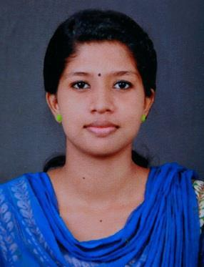

8. RAJA GUEST HOUSE

9. CHUNGATH JEWELLERY

Curriculum

Mini Project: THERMAL ENERGY TRAPPER IN EXHAUST

Projects:

Main Project: MAGLEV WINDMILL AND SOLAR HYBRID STREET LIGHT

Academics:

1) JYOTHI ENGINEERING COLLEGE,

Cheruthuruthy,Thrissur,Kerala,India. (2014 - 2018) B.tech in Electrical and Electronics Engineering-7.83 SGPA

2) SMEC Pvt. Ltd,Ernakulam.

PG in AutoCAD MEP

Electrical Designing & Drafting

HVAC Designing & Drafting

Plumbing Designing & Drafting

Fire Fighting Designing & Drafting

PRIMAVERA Software

Revit Architecture

3) DTECH ,Thrissur.

Master Diploma in Revit MEP

Personal

Details :

Date of Birth : 22-04-1996

Marital Status: Single

Nationality: Indian

Language Known: English, Hindi & Malayalam

