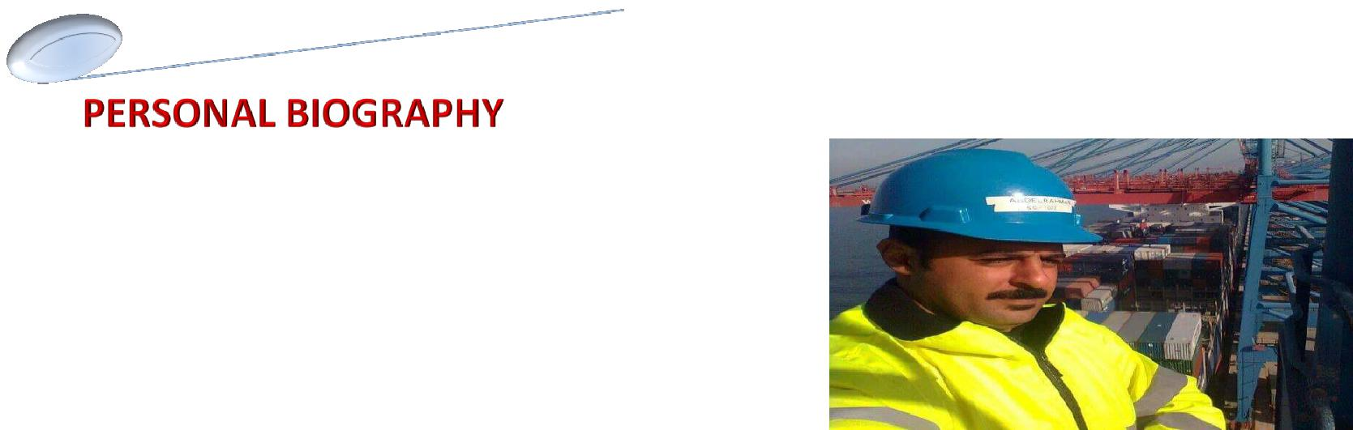

Name / ABDELRAHMAN
AGE : 34 years old
GENDER : Male

Nationality : Egyptian

Marital Status : Married and Reliable ( Three sons )

Date of birth : 02 /01/1984

Cureent address : Turkey - Istanbul

Emil Address : abdeltahman-392945@2freemail.com

Languages : Arabic – English

Qualification : High School , Military Service : Service Has Been Performed

OCCUPATION : QUAY CRANE OPERATOR - RTG OPERATOR

Duration OF Work Experience : Work Was Efficiently In Company

( SCCT )
RTG OPERATOR from ( 05/06/2006 ) until ( 31/12/2009 )
UPGRADED TO QUAY CRANE OPERATOR from
( 01/01/2010 ) until ( 30/09/2018 ) ✓

✓

✓

Skills , Experience Certificates and Training Courses : Holds Many Certificates Of Experience Internationally Accredited in This Field , and Holds Many Training Courses in The Fields Of Safety , Security .

PERSONL : Teamwork , Be Obedaient to a boss at Work and love my Frineds at Work .

THANKS

