HARIS  Contact Details  Email: haris-392946@2freemail.com  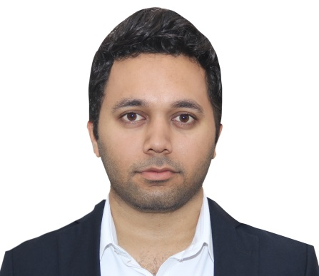  Personal Data  Date of Birth : 16/03/1987  Gender : Male  Nationality : Indian  Marital Status : Married  Mother Tongue : Malayalam  Languages : English,  Malayalam,  Hindi, Tamil,  Arabic -(Read  & Write) | Objective  - Looking for a dynamic and progressive environment where I can contribute my services, knowledge and expertise and gain further valuable experience in return.  - To Become a part of a firm that can utilize and sharpen my ability and skill  Work Experience  - From 17th July 2011 – 31st July 2016  Working as a Administrative Clerk inDUBAI  - Making outbound visas, and lodging applications  - travel plans, hotel booking, and tickets. and tracking the application with the consulates  - Accounting  - Providing support to the company through both administrative and clerical duties.  - Maintaining the office’s IT equipment.  - Involved in the typing and creation of documents as well as the processing of client information.  - Providing a high standard of service to customers.  - Printing and collating all paperwork required for the next working day  - Logging information on internal systems.  - Gathering useful and important information by phone, letter, and email or in person.  - Recording and updating customer databases.  - Photocopying and scanning administrative documents.  - Handling telephone information requests.  - Processing incoming and outgoing mail.  - Managing the security access card management system  - From 6th July 2009 – 12th April 2011  Worked as a web designer in Web Solutions ( Bangalore )  - From 2008 - 2009  Worked as a collection executive in Aircel telecom cochin ( India)  Skills & Achievements  - Excellent knowledge in Microsoft Excel, Word, Power Point. Photoshop, Dreamweaver , Image ready, Flash, Audacity  - Windows operating system 2007/2010/XP.  - Computer networking , CCNA & CCVP – (not certified)  - Computer OS installation  - Mobile servicing ( certified from Indian government)  - I have valid UAE and INDIAN driving license  - Possess pleasant manners.  - Logical thinking, Good grasping power.  - I adopt to work in a team and also individually  - Flexible and has a capacity to organize any job in a systematic manner  - Friendly, Confident, Punctual, Sincere and Hard working.

AcademicDetails
Year | Institution | - Qualification
- 2015 | Kendra Vidyalaya Tamilnadu | BBA ( Bachelor Of Business Administration )
- 2007 | Vismayam animations (A part of Calicut university ) | Web designing
2006 | NSS HSS CALICUT | Pre degree (science)
- 2004 | Government model higher secondary school Calicut | - SSLC

Declaration
I hereby declare that the above-furnished details are true to the best of myknowledge.

Place: Dubai, U.A.E

Date:

HARIS CV

