AFZAL

Planning Professional with an overall work experience of 14 years (UAE & India)

E-mail: afzal-392949@2freemail.com
PROFESSIONAL SUMMARY:

Planning Engineer, with work experience of 14 years in multi-disciplinary projects (UAE and India), with in depth knowledge of planning, scheduling, monitoring, tracking and report making.

CAREER HIGHLIGHTS:

- Development of baseline program and supporting the operation team in finalizing the progress monitoring tracker.

- Coordination with site team for program update and reporting.

- Preparation of Weekly/Monthly progress reports, and Progress Presentation for Client.

- Sub-contractor Package Management.

- Supporting Planning Manager in the preparation of EOT Claim documents.

JOB RESPONSIBILITIES:

- Preparing Schedules for the project using Primavera (P6 Version).

- Preparing Monthly/Weekly progress reports and look ahead programs.

- Preparation of Progress Monitoring Tools.

- Monitoring progress throughout various project lifecycle.

- Preparing material procurement schedule and tracking.

- Resource planning, forecasting and periodic tracking.
NAME OF EMPLOYER : (DUBAI, UAE)

POSITION PERIOD

: Planning Engineer

: April 2015 to Present

PROJECTS HANDLED:

Meydan One Mall with integrated Roads and Infrastructure & Crystal Lagoon works
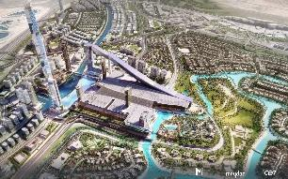

Client : Crystal One LLC

Consultant : AE7

Status : In Progress

Project Scope: Development of Meydan One Mall having a total built up area of 1.55 Million Sq.m, which consists of features including Canyon area, Water feature and fountain, office and Hotel Towers, and Ski slope. In addition, the scope included development of new roads and related infrastructure for access to Meydan One Mall (5 Multi level bridges,3 underpasses, deep and shallow utility networks), and the development
and connection of Crystal Lagoon to the main Crystal lagoon surrounding the Villas in MBRAM City,District-1

Key Performance Areas:

Page 1 of 4

- Development of detailed Baseline programme.

- Developed the procurement schedule along with the Engineering logs.

- Development of Temple Charts and project monitoring tools and daily monitoring of trackers.

- Preparation of Weekly/Monthly Reports, and Progress presentation for Client. SAFA (Dubai Water Canal Development)
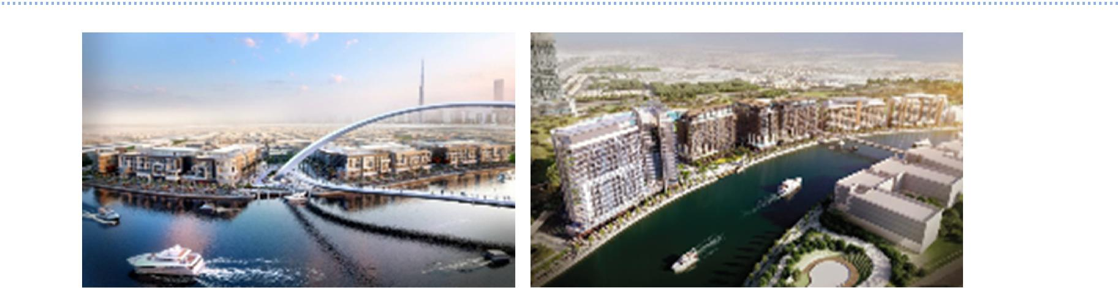

Client: The Meydan Group

Consultant: AE7

Status: In progress

Project Scope: Mixed use Commercial + Residential towers with Safa A package containing 4 buildings with a B+G+4 configuration & Safa B package containing 7 buildings with a configuration ranging from 2B+G+9 to 2B+G+15.

Phase 1 & 2 - District 1 for Meydan Sobha – Infrastructure & Building works
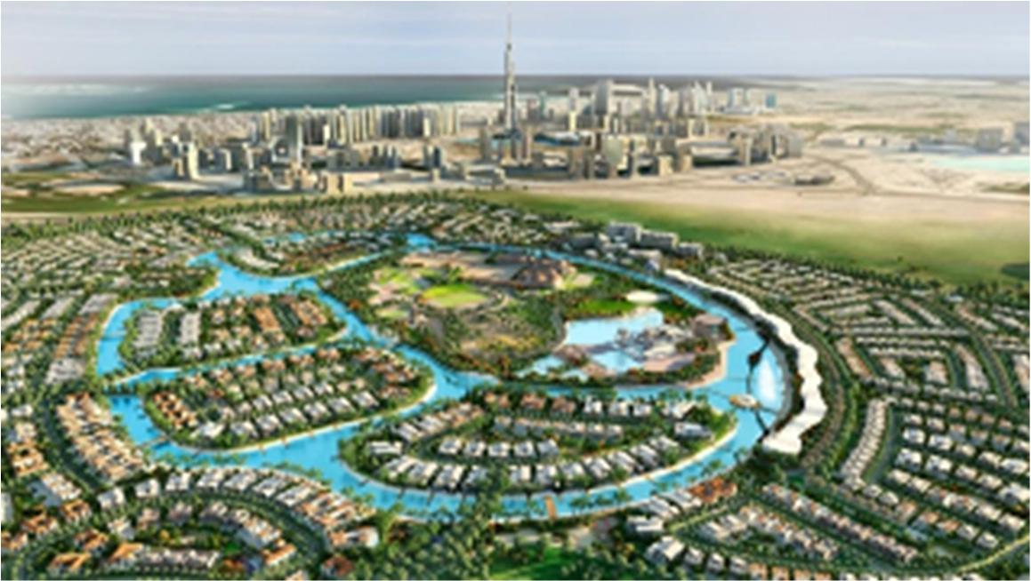

Client: The Meydan Group

Consultant: AE7

Status: Completed

Project Scope: Development of 516 Villas, external works and utility services which is part of Phases 1 & 2 of Mohammed Bin Rashid Al Makhtoum City, District-1 Project.

Key Performance Areas:

- Development of detailed Baseline programme.

- Developed the procurement schedule along with the Engineering logs.

- Development of Temple Charts and project monitoring tools and Daily monitoring of trackers.

- Preparation of Weekly/Monthly Reports.

- Subcontractor Package Management.

NAME OF EMPLOYER: (DUBAI, UAE)

POSITION PERIOD

: Planning Engineer

: Jan-13 to Mar-15

PROJECTS HANDLED:

DP-WORLD CONTAINER TERMINAL PROJECT

Client: DP World

Page 2 of 4

Consultant: Royal Haskoning

Status: Completed

Project Scope: Container Terminal Packages which was part of DP World Container Terminal project, consists of 11 buildings which include Terminal Office, Mosque, Washing bays, Welding Bays, Workshop and External Works.

THE BINARY PROJECT

Client: Omniyat

Status: Completed

Project Scope: Highrise office building located at Business Bay

Key Performance Areas:

- Worked with the team to develop the Baseline programme.

- Developed the procurement schedule along with the Engineering logs.

- Development of project monitoring tools and tracking.

- Preparing Weekly/Monthly Reports and look ahead program.

- Supporting the Planning Manager in preparation of EOT Claim documents.

NAME OF EMPLOYER : (DUBAI, UAE)

POSITION PERIOD

: Planning Engineer

: Apr-2008 to Jan-2013

PROJECTS HANDLED:

REMRAAM HOUSING PROJECT
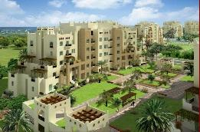
Client: MIZIN

Consultant: Khatib & Alami

Status: Completed

Project Scope: New community development near the Dubai Bypass Road (New Emirates Road). Construction, Completion and Maintenance of 56 Buildings which includes Cast in situ and Precast Structures, Finishing works and Landscaping.

PALMAROSA VILLAS PROJECT

Client: Gulf Developers FZC.

Consultant: CV TEC Consulting Engineers

Status: Completed

Project Scope: New community development near the Dubai Bypass Road (New Emirates Road). Construction, Completion and Maintenance of 192 Villas which includes Cast in situ and Precast Structural and Finishing works.

Key Performance Areas:

- Worked with the team to develop the Baseline programme.

- Preparing Weekly/Monthly reports and Look ahead Programs.

Page 3 of 4

- Develop the procurement schedule along with the Engineering logs.

- Development of project monitoring tools.

NAME OF EMPLOYER : SKYLINE FOUNDATIONS & STRUCTURES (KERALA, INDIA)

POSITION : Site Engineer

PERIOD : 2006 to 2008

PROJECT HANDLED:

CYBER PALMS PROJECT

Project Scope: Development of a community with group of 5 high-rise buildings with 14 floors each, for the first time in the area. A prestigious project in the Main Bypass road

Key Performance Areas:

- Managing the Subcontractor for the execution of Substructure and Superstructure works.

- Monitor project progress and ensure proper quality standards are followed.

NAME OF EMPLOYER : NATIONAL TRANSPORTATION PLANNING AND RESEARCH CENTRE (KERALA, INDIA)

POSITION PERIOD

: Engineering Trainee

: 2005 to 2006

ASSIGNMENTS HANDLED:

Inventory Survey for Hill Highway Proposal.

Preparation of Digital Route Map of Kerala, using Autocad Software.

Key Performance Areas:

- Collection of Road details, Type of development, technical details by doing Inventory Surveys, and compiling the details.

- Converting the old hardcopy maps to digital format with the help of Autocad Software.

- Preparing Presentations related to Traffic Management.

EDUCATION DETAILS:

- Bachelor of Civil Engineering from Anjuman Engineering College, Karnataka, India

COMPUTER PROFICIENCY:

- Hands on experience and Practitioner: Primavera P6

- Hands on experience and Practitioner: Microsoft Office

- Basic Knowledge: Autocad
PERSONAL DETAILS:
Nationality |  | Indian
Date of birth |  | 15-02-1980
Marital status |  | Married
Visa status |  | Employment visa
Linguistic skills |  | English,Hindi,Malayalam
Driving license |  | UAE driving license (valid till 2021)

DECLARATION:

I do hereby declare that the information furnished above is true to the best of my knowledge and belief. Afzal

Page 4 of 4

