RESUME
Poonam
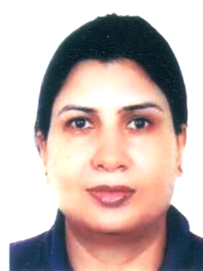

E-Mail: poonam-392959@2freemail.com
Date of Birth 21st Aug 1969
_______________________________________________________________________

PERSONAL SUMMARY

Objectives-
Want to work in challenging environment with maximum utilization of my skills and knowledge for continuous improvement and achievement of the vision of the institution.
Focused on working with students’ parent’s colleagues and administrators alike to teach and motivate students.
________________________________________________________________________

Skills -
- Good communicator
- Smart board techniques(active inspire)
- Approachable – Good listening skills.
- Passionate and energetic.
- Planning and organizational skill.
- Patience with students
- Sense of responsibility
- Dedicated to teaching students
- Professionalism
- Respectful
Computer Skill
- Diploma in software Engineering.
- Digital board (active inspire)
- Tally ERP-9.
- SAP Module.
Other Skills
- Arangetram in Indian classical dance Bharatnatyam and Mohiniattam.
- Robotics

________________________________________________________________________

Work history -

August 2017 Al Mahd Day Boarding School Saar
Current
- KS-2 -Class teacher teaching EFL teach assigned courses in accordance with the course outlines and recommended text books.
- Create a lively, communicative atmosphere in the class which is conducive to teaching and learning using smart board active inspire.
- Organising and delivering classroom lectures to students. Evaluating a students' class work and assignments.
- Preparing classroom and coursework materials to arrange any extracurricular activities and set targets.
- Recording and maintain accurate student attendance records and grades.
- Classroom management.
- Developing English lesson plans in line with the National Curriculum.
- Maintaining discipline in the classroom.
- Creating a vibrant teaching atmosphere.
Note: - Teaching Robotics, PSHE and Geography as an additional subject.

August 2016 Al Noor International School British middle section Sitra
- June 2017
- KS-3 Class teacher grade-7
- Working with students from different cultural backgrounds.
- Developing English lesson plans in line with the National Curriculum.
- Maintaining discipline in the classroom.
- Creating a vibrant teaching atmosphere.
- Developed English lesson plans in line with the curriculum:
- Planned English lessons to meet curriculum standards. (Fiction, non-fiction, Journal, Grammar).
- Helped students understand, speak, read and write in English.
- Delivered engaging, coherent lectures and motivating lessons to students across all Key Stages.
- Utilized learning technology in the planning and delivery of lessons.
- Modified assignments and activities to meet the learning needs of individual students, identified and sorted into small, similar skilled groups.

New Millennium School:-
- Worked as a teacher teaching grade 9th and 10th Social science and English. Prepare coursework and assignments for classes
- Grade tests, essays and reports, and other writing assignments
- Meet with colleagues to coordinate lesson plans and work with specific subjects of expertise
- Hold one-on-one conferences with students to keep them on track as necessary
- Meet with parents or guardians to discuss students’ academic progress, remedial issues and behavior problems when necessary.

D A V Public School:-
- Class teacher grade 6 - Teaching English, computer science middle section.
- Organizing dance classes for school functions.
- Coaching students for news reading and speeches. Adopting and working towards the implementation of the school development plan of the school.

Future School Pune:-

- Worked as a Center Head in ‘Future School Tic Tact Toe’ in India.

Responsibilities:
To supervise teachers to ensure safety of children.
Maintained updated files on attendance contact information and progress.
Outdoor activities to keep children engaged.
Ensured that all children were kept safe while at the preschool.
Attended in-service staff meetings to discuss educational goals.
Helping in promoting the school in Community.

Zygon International Business Solutions:-

Worked as Subject Matter Expert (Verbal Reasoning & English Language)

Handling batches and giving training regarding speech delivery for performance of the tasks.

BEM CO. LLC Abu Dhabi UAE:-

MEP & Facility Management. (Shifted to account as limited work in HR).
Expert in organizing events:
Organized events for- Lewis and Clark Alumni U.S.A
Account head looking after following Areas:
Responsibilities- Accounts
- Arrange approval of Local Purchase Order (LPO) & its preparation, maintaining computerized records of payments. Reporting to Chief of Accounts. Preparing invoices. Audit related updates i.e. Depreciation, File maintaining, Records keeping updating system etc. using TALLY ERP9.
_______________________________________________________________________

. Educational qualifications

- MA in English Literature
- BA in English
- B.Ed. major English
- IELTS
- Cambridge certificate in teaching and learning
- Master in Business Administration(MBA)
- Certification in Special Educational Needs(SEN)
- Human resource diploma- ICM U.K
TESOL (Post Graduate 280 hrs.)
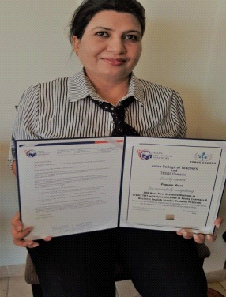

Cambridge certificate in teaching and learning,
- ESL / TESOL 280 hrs. Of extensive course. Teaching English as a first language

OBJECTIVES
I want to join a school that is looking to recruit talented individuals.
Want to work in a challenging environment with maximum utilization of my skills and knowledge for continuous improvement and achievement of the vision of the institution.

________________________________________________________________

