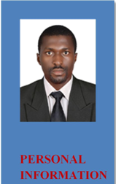
MICHAEL
CERTIFIED CHATERED ACCOUNTANT

Michael-392962@2freemail.com

PERSONAL SUMMARY

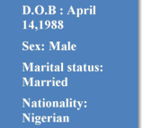
A confident, multi-skilled & capable chattered accountant with over 5 years experience (plus over 2years in UAE), having excellent skills in: Book-keeping, cash, expense, income accounts, undeposited funds, Asset and liabilities accounts. Currently working as an accountant for a major company with sole responsibility of keeping inventory records, preparing sales records, months end statement of account, currently seeking a position in any industry.

SKILLS

Microsoft Excel

Tally ERP

Peach tree

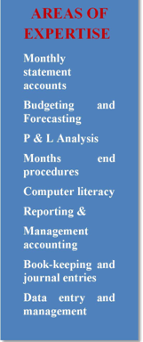
Multitasked

Strategic thinking

Development insights

Good Communication skills both oral and written

Customer satisfaction oriented

Team member and presentation skills

PROFESSIONAL WORK EXPERIENCE:

Supporting the Venture by assisting to produce accurate Financial and management accounting information on which financial decisions are based.

DUTIES

ACCOUNTANT MANAGER

2017-2019

- Responsible for timely payments of loans grants and bills.
- Monitoring and processing payments and expenditures.
- Preparing the organization payroll systems.
- Review the financial reports and submit to board of directors for further documentation and use.

- Maintaining accounting records by making copies, filing and documents.
- Reconcile bank statements by comparing statements with the general

ledger

- Issues checks for accounts payable.
- Perform accounting and clerical functions to support supervisors.
- Open mails, match payments to invoices while updating system database.

UAE ACCOUNTANT
DUTIES 2015-2017
• Preparing asset, liability and capital account entries by compiling and analyzing
accounting data and information.

- Document financial transactions by entering account information.
• Reconciles financial discrepancy by collecting and analyzing accounting information.
- Summarizes current financial status by collecting relevant information after preparing

profit and loss statement, balance sheet, and other reports like IFRS and IRS.
• Providing financial information to the management by researching and analyzing
accounting data and statistics.

- Maintaining financial security by following internal controls.
• Maintains customer confidence and protects operations by keeping financial information confidential.

ACADEMIC QUALIFICATIONS

➢ Chinese language training programme
Nanchang University, Jiangxi province, China |  | 2019
➢ MSc. Public Administration (MPA)
Adekunle Ajasin university, Nigeria |  | 2018
➢ Association of chartered Certified Accountant ACCA |  | 2017
➢ Institute of chartered Accountants Nigeria. | ICAN | 2016
➢ National Youth service corps with ICT skills acquisition |  | 2015
➢ BSc. (Hons) Accountancy
Adekunle Ajasin university, Nigeria |  | 2014
➢ Higher Diploma In Economics and statistics
School of basic studies AAUA, Epinmi Campus |  | 2010
➢ Advanced Financial Management
National business and technical examination board |  | 2010
➢ Diploma in Desktop Publishing
Jerro Computers, FCT. Nigeria. |  | 2008

PROJECT WORK, RECOMMENDATIONS AND AWARDS.

Auditing and Auditors independency in the public sector

(Partial fulfillment of the requirement for award of BSc. in Accountancy) 2014

Letter of commendation National youth service corps, Kogi state of Nigeria.

(Office of the accounts officer) | 2015
Certificate of performance (NYSC) Kogi State chapter | 2015

