ALBIN
albin-392968@2freemail.com

CIVIL SITE ENGINEER 4 YEARS OF EXPERIENCE IN UAE

Seeking Civil Engineering level assignments in various Construction Field with an organization of repute.

TARGET JOB

Target Job title : Construction Industry Career Level : Mid-Level
Target Job location : United Arab Emirates

SYNOPSIS

A highly talented, professional and dedicated civil Engineer. Having overall 6 years of experience in the field of Civil Engineering, engaged in Various Construction of Residential Building & Commercial Building and Looking up for a challenging opportunity in an esteemed concern, offers to prove my analytical abilities and expertise in planning and co-ordinating client, result oriented, quick and logical decision maker on arranging resources through internal department, ability to manage pressure and deliver consistent result. My honesty and sincerity towards the work is the key to my professional life.

EDUCATIONAL QUALIFICATION

Bachelor’s Degree in Civil Engineering
Under Anna University 2011-2014

Diploma in Civil Engineering
Under State Board of Technical Education 2007-2010

Master Diploma in Civil Cad
Certified Courses

Technical Skills

Familiar with All Civil related Software and Instruments, like

MS OFFICE (Excel and word)

- AUTO CADD( Creating Plan & 3D)

REVIT ARCHITECH
- PRIMAVERA

EMPLOYMENT EXPERIENCE

- M/s GHANTOOT TRANSPORT AND GENERAL CONTRACTING L.C.C
(An Integrated Management System (IMS) Certified Organization)

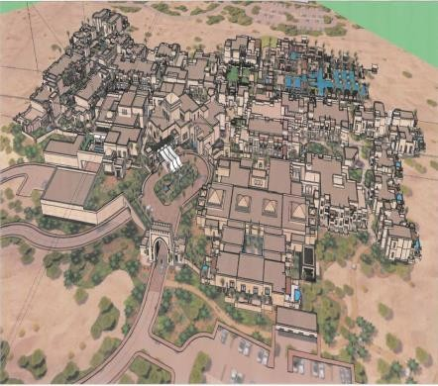
Site Engineer: April 2015 up to April 2019

Project Name : Five Star Desert Resort Hotel (DesertResort) Client : H.H. Sheikh Mansour Bin Zayed Bin Sultan Al Nahyan Engineering Office.
Consultant : GAJ Middle East Architecture & Civil Engineering Project Zone : 6 Zones (Main Hotel, All Day Dinning, Talise Spa
Building Specialty Restaurant, Conference Hall, Swimming pool Bed Room Block Building (10 No’s)
Designation :Site Engineer
Duration : April- 2015 to December -2016

Project Name : Five Commercial High Race Buildings at Al Raha Beach (3B+G+13) Client : ADCE
Consultant : Heberger Architecture & Civil Engineering Consultant
Designation : Site Engineer (worked also as QA/QC Engineer in the absence of the Designated person).
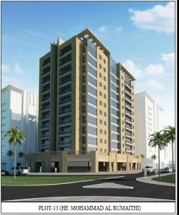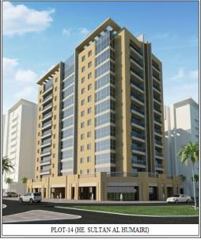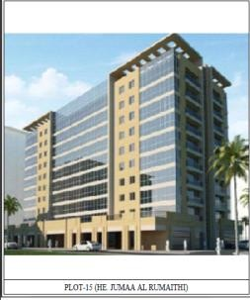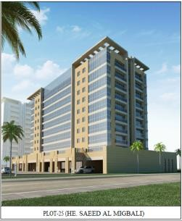Duration : December 2016- to June 2018.

Project Name : Abu Hail Clinic New Health Center (B+G+2) Client : Dubai Health Authority [Government of Dubai] Consultant : HDP [Healthcare Designers and Project Managers]
Designation : Site Engineer (worked also as QA/QC Engineer in the absence of the designated person).
Duration : June 2018- to April 2019.

India Experience in Construction Work

Company : Cee Dee Yes Infrastructure Development (p) Ltd, chennai Duration : June 2010 to May 2011
Position : Site Engineer.

Company : B G Shrike Construction Tech (P) Ltd, Bangalore Duration : May 2014 to January 2015
Position ; Site Engineer

Role & Responsibility in M/s /s GHANTOOT TRANSPORT AND GENERAL CONTRACTING L.C.C

  - Acting as the Site In charge for Structural & Architectural along with technical construction site for Forman, Charge Hands & coordinating with sub-contractors for various site activities and preparation of Inspection request and getting approval from Consultant for various Construction activities.
  - Providing approved Documents & Drawings and detailed instruction & Specification for Structure & Finishing which is to be executed to the Forman and Charge hands.
  - Resolving any unexpected technical difficulties and other problems that may arise, by Coordinating with design department & technical department, if there are any issues with Shop drawings.
  - Monitoring the HSE during execution of the work and taking responsibility for health and safety on site, ensure quality of workmanship.
  - Ensure that all materials used & work performed are as per specification & Methods of Statements line with work crew are properly supplied withtools,equipment’s and Monitoring the Quality control in accordance with CSIs/procedures method statements.
  - Preparing and Raising the Inspection Request of Construction activities, Coordinating &Assisting with QC Engineer, Consultant for construction work until Inspection is done & approved.
  - Preparing Daily allocation& Progress Report of the work to Project Engineer & Sr. Construction Manager.

Role & Responsibility

    - Preparing the approvals of variation quantity, against scheduled quantity.
    - Conduct Design and coordinate meetings with Client & Consultant.
    - Control & Monitor drawing, tracking with Foreman & Supervisors.
    - Prepare daily progress reports according to the schedule.

- Planning & Estimation
- Structural Designing
- Quality Control
- Site Work

AREA OF INTEREST

PERSONAL DETAIL

Date of Birth : 30-07-1988
Gender :Male
Marital Status : Married
Nationality : Indian
Languages Known : English, Hindi, Arabic, Malayalam and Tamil. Qualification : DCE / B.E (Civil Engineering)
Work experience : 4 years in UAE
Profession : Civil Engineer (Site Engineer)
Visa Status : Visit Visa

