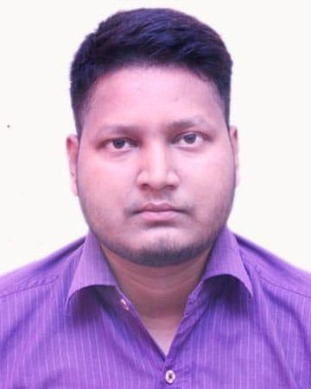
Amandeep

E-mail ID: amandeep-392974@2freemail.com

PERSONAL ABILITIES AND SKILLS

- Excellent ability to establish good relaonship with people

- Reliable and responsible

- Convincing skills with a logical mind.

- Management skills, work as team or group leader.

- Strongly commied to assigned work.

- Proficient with computer literate.

- Internet and email.

Strengths:
Punctual

Hardworking

Self-Confident

OBJECTIVE

To work in an environment that will help me in contribu]ng towards the goals of the organizaon and connuously upgrade my knowledge.

ACADEMIC

Qualification | Year passed | Board/ University | Percentage %
B.A | 2014 | Kanpur University | 58
XII | 2010 | C.B.S.E Board | 61
X | 2008 | C.B.S.E. Board, | 45.2

WORK EXPERIENCE

- 3 Years Experience with Dish TV India PVT LTD As Admin and attendance payroll.

- 2 Years Experience with Radiate E-Services PVT LTD As Senior management officer.

Duties and Responsibilities

- I was take care of all visitors As Administrave o cer.

- I was take care of all employee aendance and payroll and responsible for salary and incenve distribu]on as a account execuve.

- I was take care of all candidate who was come for interview help to conduct their interview.

- I was also take care all the stocks and goods for admin team and pantry and arrange all the required things too as administrave.

- I was take care of admin team and give guidance how to complete his/her task on decided TAT.

COMPUTER PROFICIENCY

- I have all the knowledge of computer (M.S Word, Adv. Excel & Internet) along with 50 WPM typing speed.

- I have Email equee which is refers to the principles of behavior that one should use when wring or answering email messages

LANGUAGE [Written & Spoken]

Languages: English and Hindi.

 | PERSONAL DETAILS
D.O.B | : 08-08-1993
Gender | : Male
Naonality | : Indian
Marital Status | : Single

Hobbies:
- Travelling.

- Bike Riding

(AMANDEEP)

