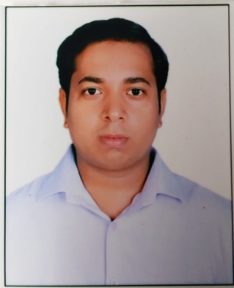
RESUME

Krishna
E-Mail - Krishna-392976@2freemail.com

Job Objective
To work for the organization with my ability, efficiency and to take every responsibility and accept all challenges given to me for personal as well as professional growth.

Research Work & Experience
- I have 2.5 Years Experience with Dish TV India Private LTD As a Sales executive and my responsibility listening to customer requirements and presenting appropriately to make a sale of Dish TV Connection.

- I have 2 Years Experience with HomeShop18 As a Sr. Sales executive and my responsibility is to provide superlative information about product like Electronic, Mobile, Grocery, Apparels etc. for any customer from the stage of product selection and placing the order.

Academic Qualification

- Bachelor of Arts (BA) with Delhi University in 2015.
- Intermediate with CBSE Board in 2011
- High School with CBSE Board in 2009.

Computer Proficiency
- I have all the knowledge of computer (M.S Word, Adv. Excel & Internet) along with 40 WPM typing speed.

- I have Email etiquette which is refers to the principles of behavior that one should use when writing or answering email messages

STRENGTH:
- Punctuality, Honesty, Smart Work, Quick Learner.

PERSONAL DETAILS:
Date of Birth : 03/02/1994
Language Known : Hindi, English
Marital Status : Married
Gender : Male
Nationality : Indian
Hobbies : Listing Music.

DECLARATION

- I hereby declare that all the information furnished above is true and best according to my knowledge and belief.

DATE: (Krishna)

PLACE:

