GAAFAR

Email: gaafar-392987@2freemail.com

Area: Dubai ,UAE
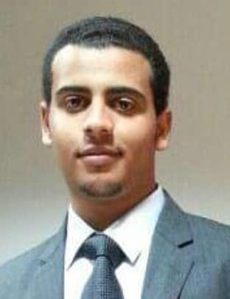

PERSONAL PROFILE

To become an excellent Civil Engineer taking up Challenging Works in the Industrial structure, Building, Towers etc., with creative and diversified Projects & to be part of a Constructive & Fast Growing World.

PERSONAL INFORMATION

Birth Date | : | 31/01/1995
Birth place | : | saqult,sohag
Nationality | : | Egyptian
Marital status | : | single

CAREER INTEEREST

Seismic resistant design of R.C.C building

Airport pavements

Construction management

EDUCATION

B.TECH Engineering Degrees

Civil Engineering 2012-2016

Department of civil engineering ,Aligarh Muslim University ,Aligarh ,India

High School

10+2, 2010-2012

AL-khaleej secondary school, Dammam ,Saudi Arabia

RELEVANT WORK EXPERINCE

Sept,2016- Jun 2017 : Saudi

Project : king Fahd hotel (Basement and G+10 floor)

Position : site engineer

Responsibility : checking formwork, reinforcement.

Making sure the project complies with authorities requirement .

Dec.2017-Feb 2109 : Sohag,Egypt

Project : Tower of Sama( basement and G+7floor)

Position : site engineer

Responsibility : checking formwork, reinforcement, Ordering concrete and all embedded items .

Ensuring that all work is completed on time within agreed budget.

OTHER WORK EXPERIENCE

Vender perfumes and beauty

SOFTWARE SKILLS

Operating system | : | windows, Mac , android
Office Exposure | : | Microsoft office
Software | : | STAAD Pro, FAARField .AutoCAD ,Primavera,

PERSONAL INTEREST

Travelling

Playing football

Looking for new thing

SPOKEN LANGUGE

Arabic :( mother language)

English :(Excellent)

Urdu :(fine)

