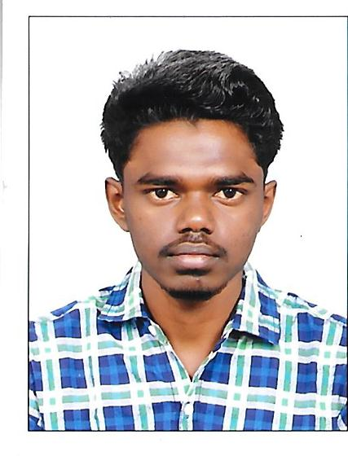

MARTIN
martin-392994@2freemail.com

CAREER OBJECTIVE

To work for an organization which provides me the opportunity to improve my skills and knowledge to growth along with the organization objective.

Personality Traits

- Familiar with internet applications & computer literate.
- Can handle the situation.
- Active in games.
- Good leadership & communication skills.
- Smart with ability to work hard and learn quickly on the job.
- Ability to co-ordinate efficiently with different teams.

EDUCATIONAL QUALIFICATION

Course/class | School/college | percentage | Year of passing
10th | Seyad Residential School | 69 | 2011
12th | Seyad Residential School | 63 | 2013
BBA | JP College of Arts and Science | 60 | 2016
MBA | Hindusthan College of Arts and Science | 72 | 2018

EXPERIENCE

- Sales manager – KS AGENCY, Tenkasi
- Worked during period of August 2018 – May 2019
- 10months experience

EXPERTISE

- Marketing
- Problem solving

PERSONAL DETAILS
Date of Birth: 8th October, 1995
Nationality: Indian
Marital Status: Single
Languages known: English & Tamil
Visa Details: Visit Visa

