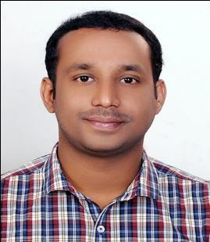

CIJO
Android/IOS Developer

4 years of professional experience Indian | Single | Employment Work Visa cijo-392996@2freemail.com

OBJECTIVE

A pioneering and security-oriented developer offering more than four years of experience in designing, implementing, integrating, testing and supporting impactful applications developed in diverse, collaborative environments for mobile and tablet devices on the Android and IOS platform.

EXPERIENCE

Sl. | From | To | Company | Designation
No
1 | February | Currently |  | Software Engineer
 | 2018 | Working
 |  |  | Deira, Dubai
2 | May | May | iROID Technologies, | Android Developer
 | 2016 | 2017 | Cochin, Kerala
3 | January | May | Reubro International, | Junior Programmer- Android
 | 2015 | 2016 | Cochin, Kerala
4 | April | November | Appzoc Technologies, | Android Developer Trainee
 | 2014 | 2014 | Cochin, Kerala

TECHNICAL KNOWLEDGE

Programming | C, C++, Java, Swift
Languages
Database | Sqlite
Parsing techniques | JSON Parsing and XML Parsing
Tools | Eclipse, Android Studio , Xcode

ACADEMIC QUALIFICATION

SlNo | From | To | Course | Institute/University
1 | 2009 | 2013 | B.E Computer | Anna University Chennai
 |  |  | Science and
 |  |  | Engineering

Current Project:

Project Title :
Environment :

Warash and Warash partner
Android studio and Xcode

Description :

Warash is an Automobile application built in both Android and IOS platforms.

.

Android versions:

https://play.google.com/store/apps/details?id=com.warash.app&hl=en https://play.google.com/store/apps/details?id=com.warash.admin&hl=en

IOS versions:

https://itunes.apple.com/ae/app/warash-search-workshops/id1196213003?mt=8 https://itunes.apple.com/ae/app/warash-partner/id1196667170?mt=8

OTHER SKILLS
ANDROID |  | C,C++ | GOOGLE+ API | PAYPAL
CORE JAVA |  | JSON | FACEBOOK API | PAYUMONEY
XML |  | FIREBASE | TWITTER API | PAYUBIZ
SQLITE |  | COMETCHAT | MAPS API | STRIPE
IOS |  | SWIFT

PERSONAL PROFILE
Date of Birth |  | : 04/02/1991
Languages Proficiency |  | : English, Malayalam, Tamil.
Hobbies |  | : Listening music, watching movies, playing cricket

Gender
Marital Status
Nationality

: Male
: Single
: Indian

DECLARATION

I hereby declare that, all information provided here with holds true to the extent of my knowledge.

[Cijo]

