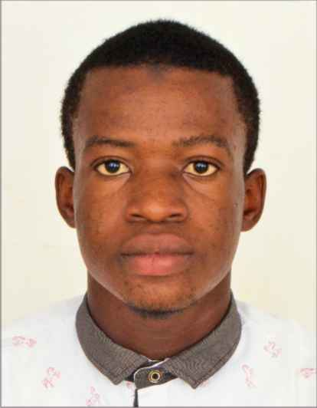
CURRICULUM VITAE (CV)
PERSONAL INFORMATION
NAME:
YAHUZA
NATIONALITY,RELIGION  GHANAIAN  ISLAM | EMAIL:  Yahuza-393012@2freemail.com | Date of birth:  7th MAY,2001
LANGUAGES SPOKEN:  ENGLISH,TWI AND HAUSA | MARITAL STATUS:  SINGLE
PROFILE
A PROFESSIONAL SECURITY GUARD WITH EXCELLENT SECURITY INTELLIGENCE AND PROPERTY MANAGEMENT SKILLS. ACTION ORIENTED WITH STRONG ABILITY TO COMMUNICATE EFFECTIVELY WITH TECHNOLOGY, EXECUTIVE AND BUSINESS AUDIENCES. DEMONSTRATED ABILITY TO COMPLETE TASKS ACCURATELY DESPITE INTERRUPTIONS AND COMPETING DEMANDS.
SKILLS and qualities
QUICK LEARNER | EXCELLENT COMMUNICATION | TIME MANAGEMENT SKILLS
PROBLEM SOLVING SKILLS | ADAPTABLE TO NEW SITUATIONS | POSITIVE ATTITUDE TOWARDS WORK
COMPUTER LITERATE | SECURITY INTELLIGENCE | KNOWLEDGE ON MODERN TECHNOLOGY
INSTITUTIONS ATTENDED AND QUALIFICATIONS
NAME OF INSTITUTION | LOCATION AND DATE ATTENDED | QUALIFICATION
CHRIST REVOLUTIONARY INTERNATIONAL SCHOOL | ABOABO-DAGOMBALINE, KUMASI  GHANA, WEST AFRICA  (2003-2015) | PRIMARY AND JUNIOR HIGH SCHOOL DIPLOMA(BECE)
KUMASI SENIOR HIGH TECHNICAL SCHOOL | PATASE, KUMASI, GHANA  WEST AFRICA  (2015-2018) | SENIOR HIGH SCHOOL DIPLOMA(WASSCE)
ACE CONSULT(EDUCATION USA) | ASOKWA(TOP MARTINS BUILDING,3RD FLOOR), KUMASI, GHANA, WEST AFRICA
WORK EXPERIENCE
COMPANY NAME | LOCATION | DURASION
G4S GHANA | LABONE, ACCRA, GHANA | 2 YEARS  (2017-CURRENT)

