DHANUSHKA
HND (QS) / B.Sc. (Hons.) QS

Email |  | : dhanushka-393014@2freemail.com
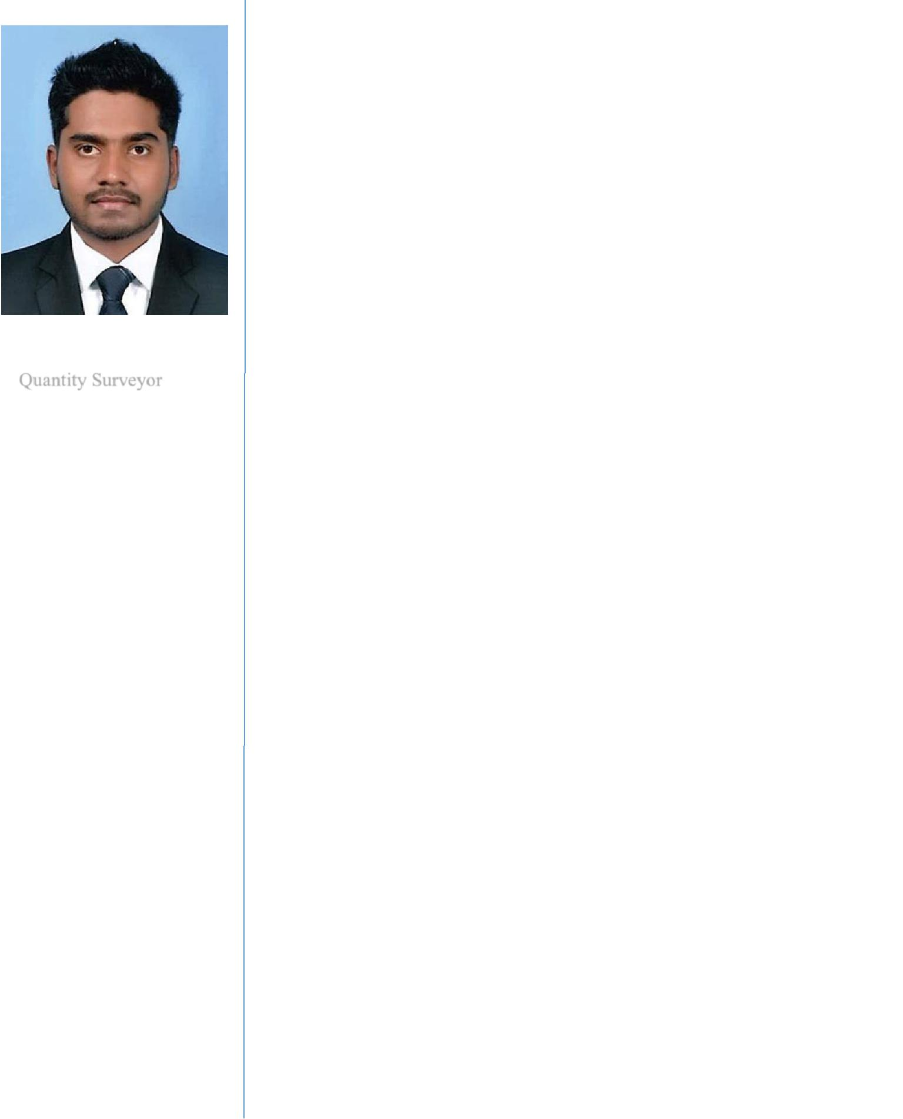

POSITION

Quantity Surveyor

DESCIPLINE

Cost Management

PROFESSIONAL QUALIFICATIONS
- B.Sc. (Hons.) in QS

- HND in QS (NVQ 6)

CORE SKILLS

- Quantity takeoff

- BoQ preparation

- Interim payment application and certification

- Sub-Contract management

- Report writing

- Negotiation skills

DETAILS OF PROFESSIONAL MEMBERSHIPS

- IQSSL – Student Member

I am a Quantity Surveyor who has over 4 years’ experience with different Quantity Surveying roles for both contractor and consultancy companies in Sri Lanka. I am seeking a dynamic role in a challenging construction environment, to face it with fullest dedication and to be engaged in providing the acquired knowledge and skills to enrich the work environment, while developing the current abilities and enhancing the interpersonal skills.

Key Work Experience

- Quantity Surveyor

(July 2016 – July 2019)

Cost consultancy organization

- Take off civil engineering works, building works, MEP and ID works.

- Squaring and abstracting quantities of measured works.

- Preparation of computer aided Bill of Quantities.

- Evaluation and certifying of package Contractor’s Claims.

- Attending and contributing to site visits and meetings.

- Inspection of work done at site.

- Evaluation of Variations

- Collection and compilation of cost information.

- Evaluation of Final accounts. Of following projects,
- Panorama Residential Townhouse, Qatar.

- Proposed Luna Tower Apartment Complex in Colombo, Sri Lanka, for Consultant’s party. Project Value SLR 7000M (US $ 45.2M)

(From April 2017 to July 2019)

- Proposed building for warehouse facility in Kotugoda, Sri Lanka, for

Consultant’s party. Project Value SLR 1700M (From November 2018 to July 2019)

- Proposed Pledgescape Hotel in Negombo, Sri Lanka, for

Consultant’s party. Project Value SLR 970M, Including Piling. (From July 2016 to July 2019)

METHOD OF MEASUREMENTS

- POMI

- CESMM 3/ CESMM4

- NRM 1 & 2

- SLS 573

SOFTWARE SKILLS

- AutoCAD

- Microsoft Office

- MS Project

- Plan Swift

- Cost X

EMPLOYMENT HISTORY

- CML-MTD Construction Ltd

- cost management services (pvt) ltd

OTHER

QUALIFICATIONS

- Diploma in English at Aquinas University College.

- Trainee Quantity Surveyor

(January 2016 – July 2016)

Cost consultancy organization

- Take off quantities. (Civil, MEP & ID)

- Preparing of BoQs.

- Evaluation of contractor’s submitted interim valuations.

- Inspection of site works and joint measurements.

- Evaluation of Rate analysis. Of following projects,
- Al Fahidi Residential Building, Dubai.

- Panorama Residential Townhouse, Qatar.

- Proposed Pledgescape Hotel in Negombo, Sri Lanka, for

Consultant’s party. Project Value SLR 970M, Including Piling.

(From January 2016 to July 2016)

- Proposed CIC factory building complex in Panagoda, Sri Lanka.

- Proposed warehouse building for Lanka Canneries (pvt) ltd in Narahenpita, Sri Lanka

  - Trainee Quantity Surveyor

(July 2015 – January 2016)

Civil contracting organization

- Take off quantities.

- Preparation of Interim Payment Applications.

- Evaluation of sub-contractor’s interim payment applications.

- Inspection of site works and joint measurements.

- Preparation of variation claims.

- Preparation of Rate analysis.

- Preparation of labour records.

Of Urban Regeneration Project, at city of Colombo, Construction of 576 Housing units. Project Value SLR 2304M (US $ 16.5M) (From July 2015 to January 2016)

Personal Profile

Name in Full

Date of Birth

Gender

Civil Status

Nationality

: Dhanushka

: 24.02.1993

: Male

: Single

: Sri Lankan

I hereby do certify that the above details are true and actual to the best of my knowledge.

Dhanushka

